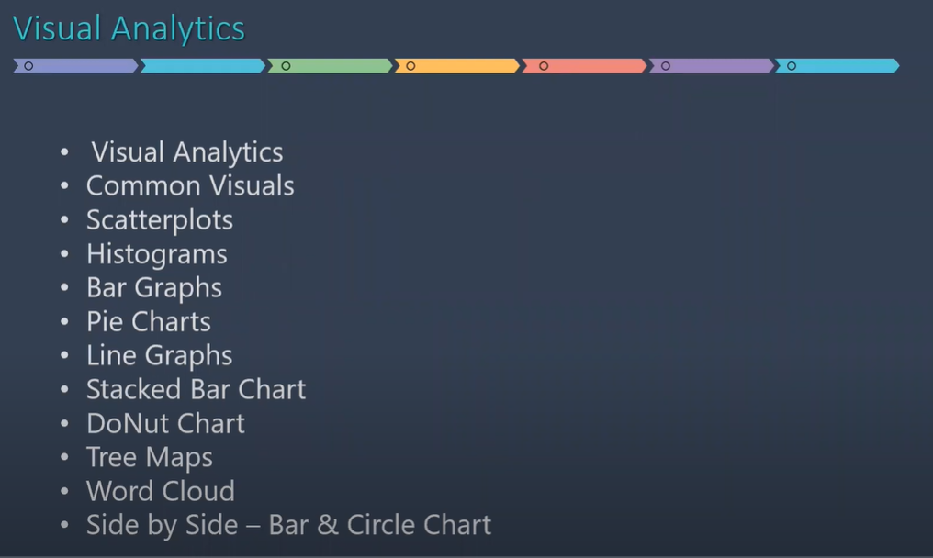

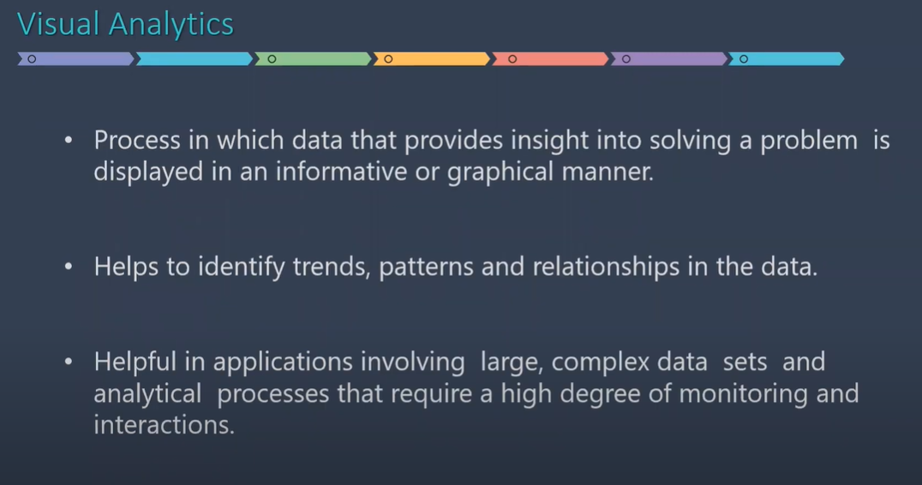

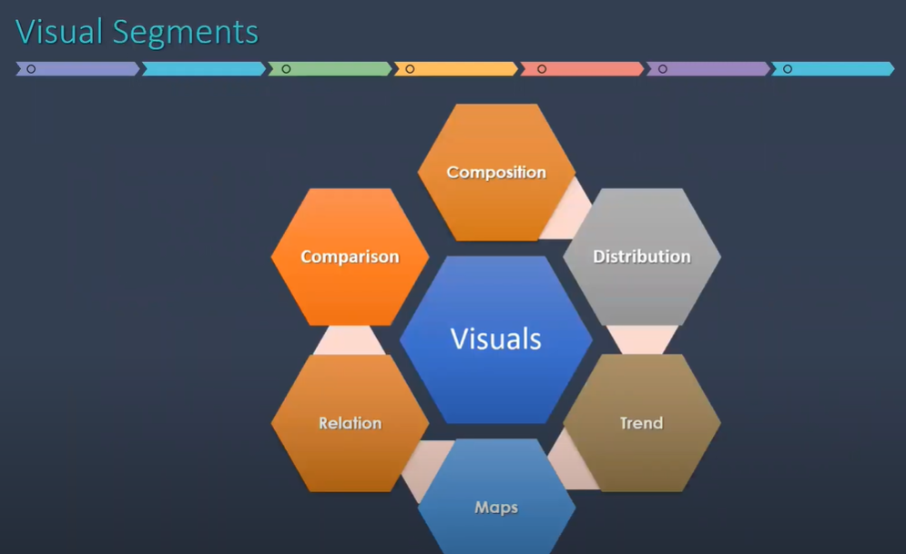

| CHART | DESCRIPTION |
| --- | --- |
|  | Line — Viewing trends in data over time.  Examples: Stock price change over a five-year period, website page views during a month, revenue growth by quarter. |
|  | Bar — Comparing data across categories.  Examples: Volume of shirts in different sizes, website traffic by origination site, percent of spending by department. |
|  | Heat Map — Showing the relationship between two factors.  Examples: Segmentation analysis of target market, product adoption across regions, sales leads by individual rep. |
|  | Highlight Table — Providing detailed information on heat maps.  Examples: The percent of a market for different segments, sales numbers in a particular region, population of cities in different years. |
|  | Treemap — Showing hierarchical data as a proportion of a whole.  Examples: Storage usage across computer machines, managing the number and priority of technical support cases, comparing fiscal budgets between years. |
|  | Gantt — Showing duration over time.  Examples: Project timeline, duration of a machine’s use, availability of players on a team. |
|  | Bullet — Evaluating performance of a metric against a goal.  Examples: Sales quota assessment, actual spending vs. budget, performance spectrum (great/good/poor). |
|  | Scatterplot — Investigating the relationship between different variables.  Examples: Male versus female likelihood of having lung cancer at different ages, technology early adopters’ and laggards’ purchase patterns of smart phones, shipping costs of different product categories to different regions. |
|  | Histogram — Understanding the distribution of your data.  Examples: Number of customers by company size, student performance on an exam, frequency of a product defect. |
|  | Symbol maps — Use for totals rather than rates. Be careful, as small differences will be hard to see.  Examples: Number of customers in different geographies. |
|  | Area maps — Use for rates rather than totals. Use sensible base geography.  Examples: Rates of internet-usage in certain geographies, house prices in different neighborhoods. |
|  | Box-and-Whisker — Showing the distribution of a set of a data.  Examples: Understanding your data at a glance, seeing how data is skewed towards one end, identifying outliers in your data. |

**Visual Segment: Relation**

Best plot for this segment is scatter plot

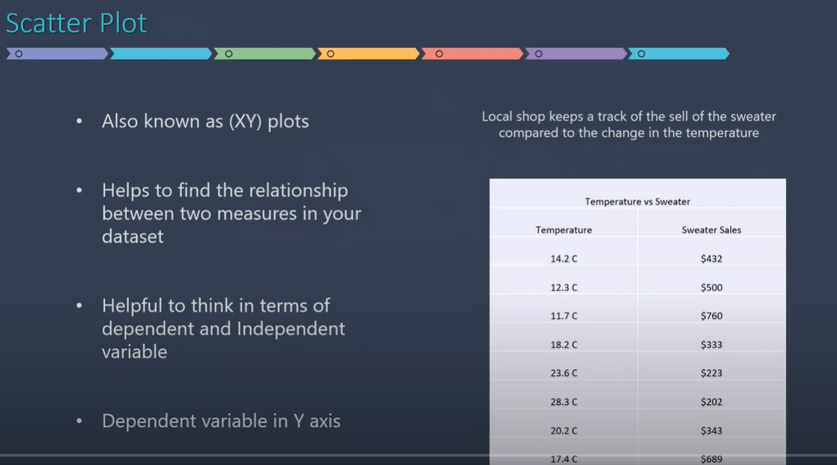

In case of scatter plot, we have to identify dependent and independent variables.

Here, as the temperature is decreasing the sales is increasing and as the temp goes up, sales goes down.

* Dependent Variable: Sweater Sales
* Independent Variable: Temperature

Open Tableau 🡪 Text File

Source: CarMakers.csv

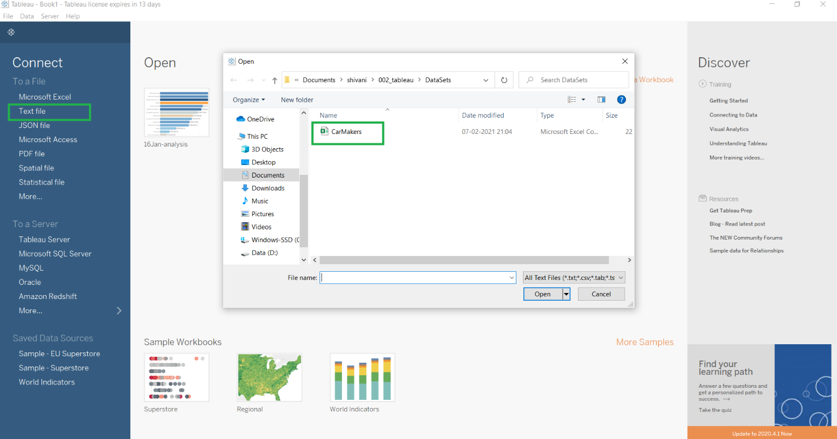

Requirement A: A friend needs to buy a car where his budget is 30,000 dollars and horsepower>=150

After importing the dataset, check the fields in dimensions and measures if they are in the proper category.

Then, using point and click method:

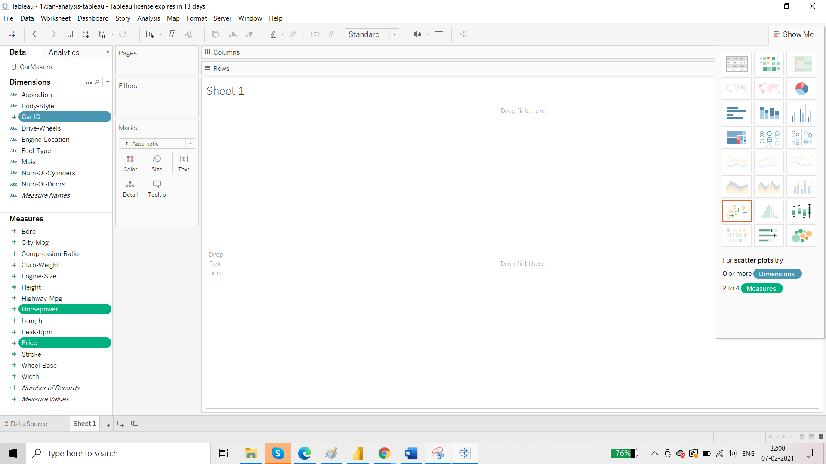

Select Scatter Plot

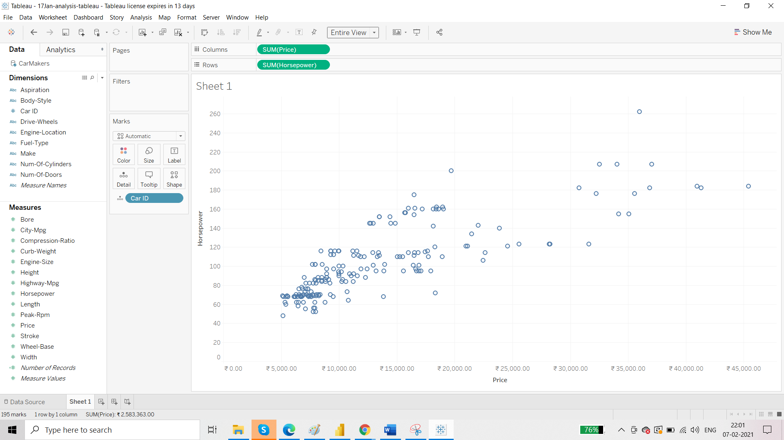

Now check the axis. Dependent variable should be on y axis.

As horsepower increases, price increases and vice versa. So price is dependent variable and thus should be present on Y-Axis.

So we have to switch the axis here.

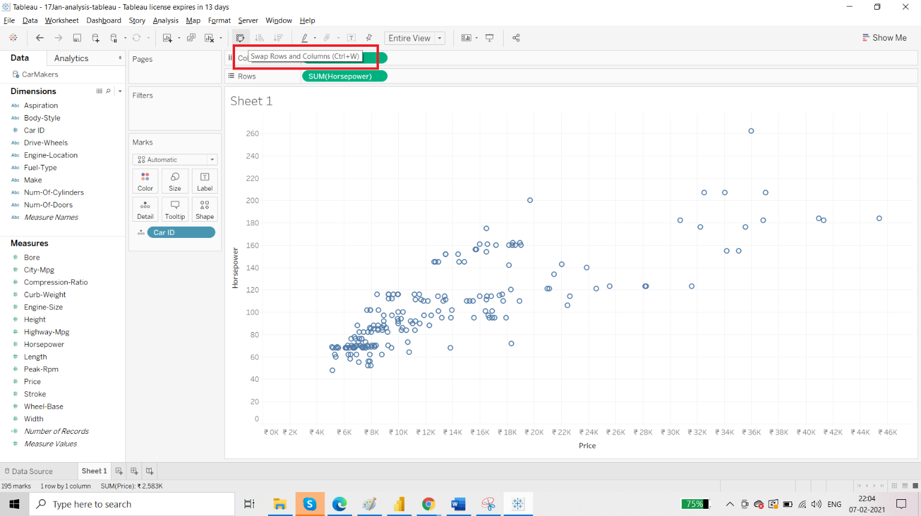

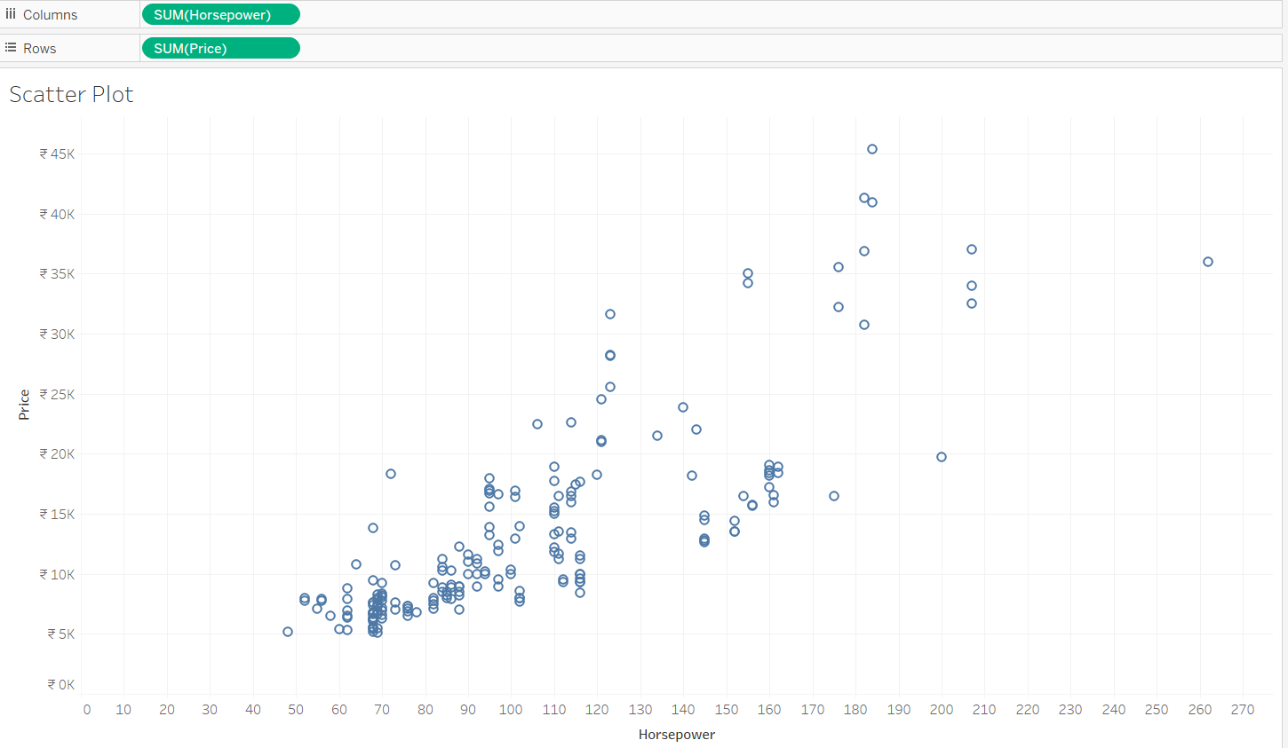

Now we will draw reference line as per our requirement.

**Requirement 1: more than 150 horsepower**

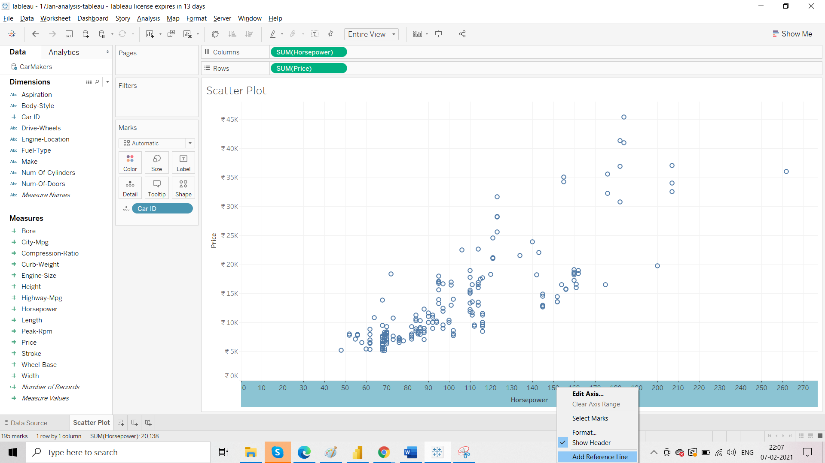

As per the given requirement:

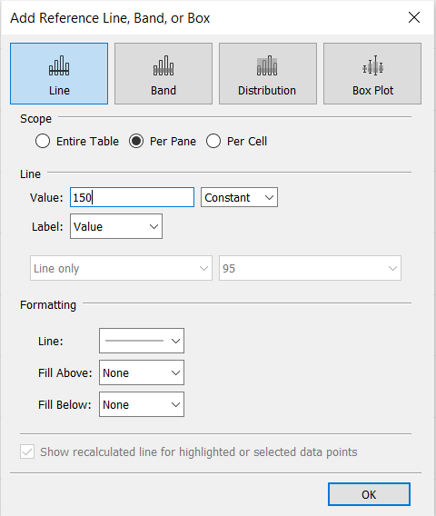

Then click OK.

**Moving on to Requirement 2 : price should be less than 30,000**

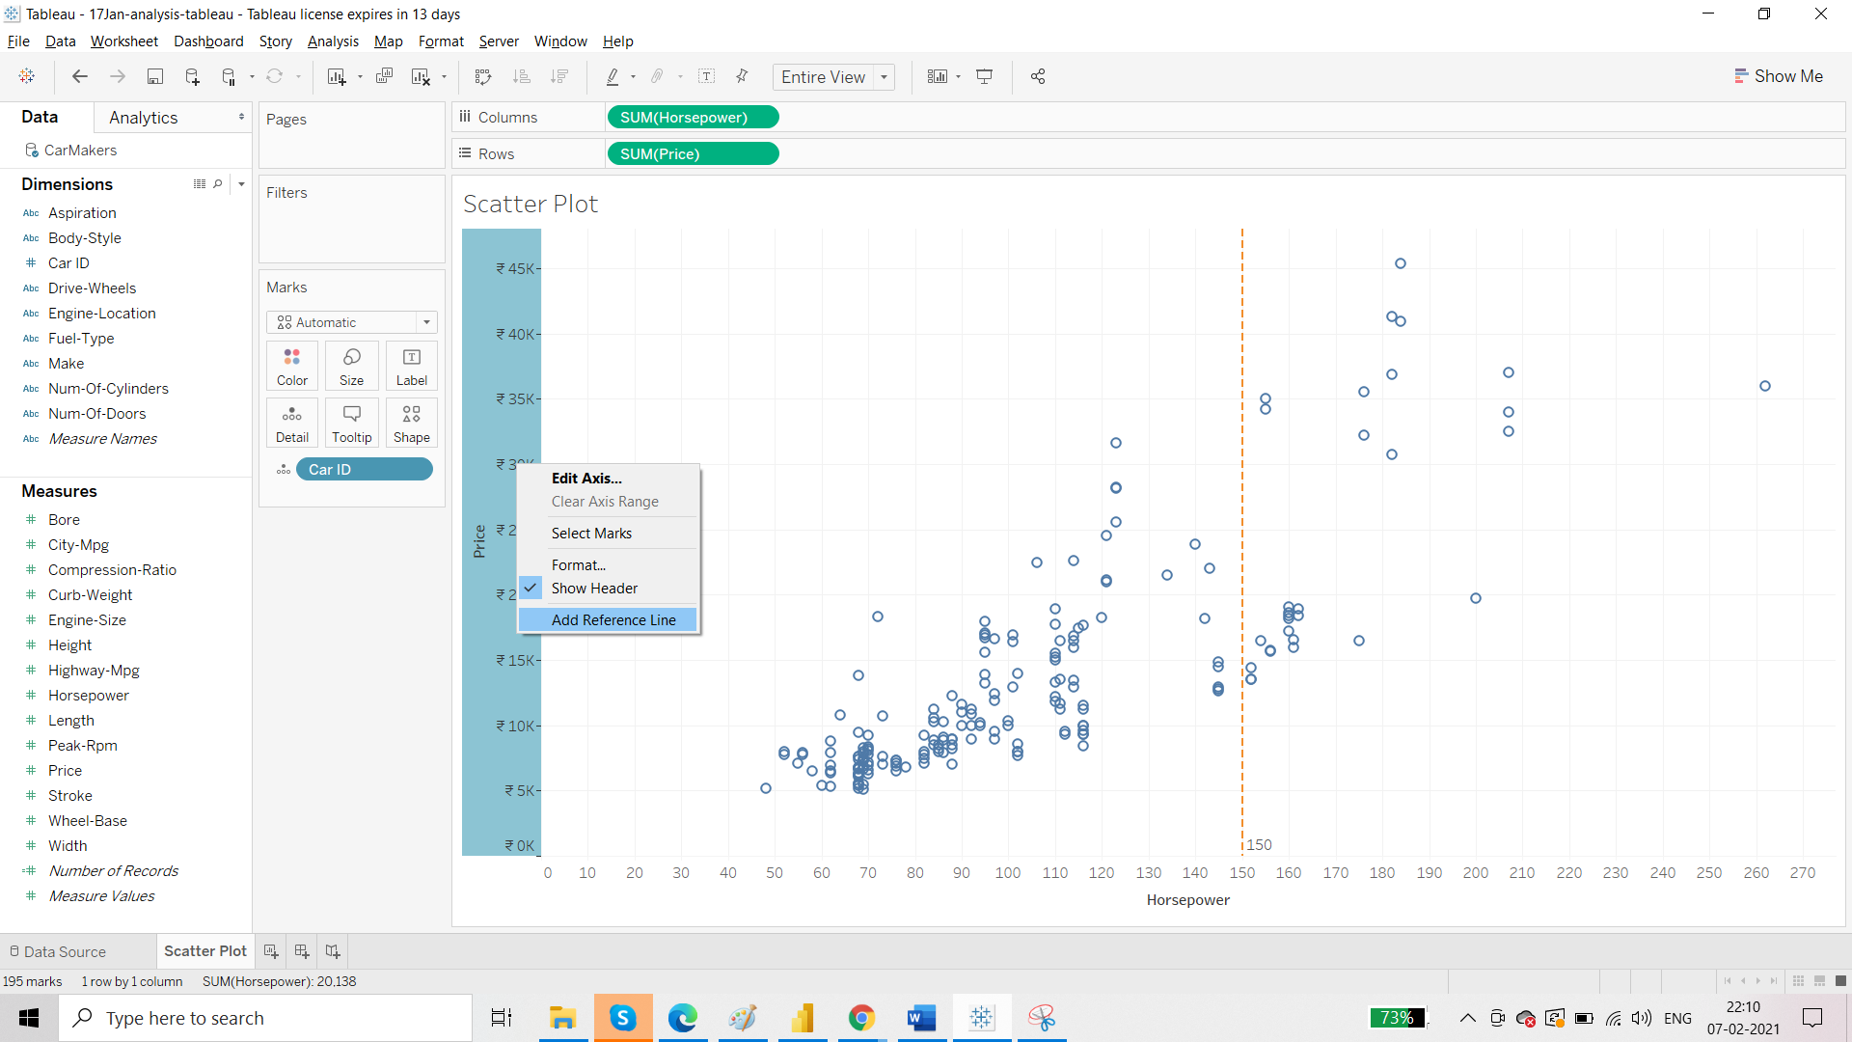

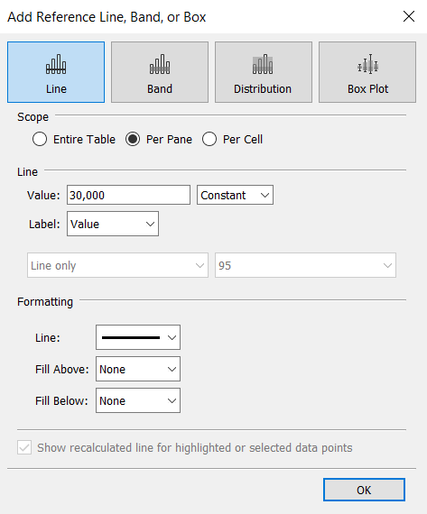

Click OK.

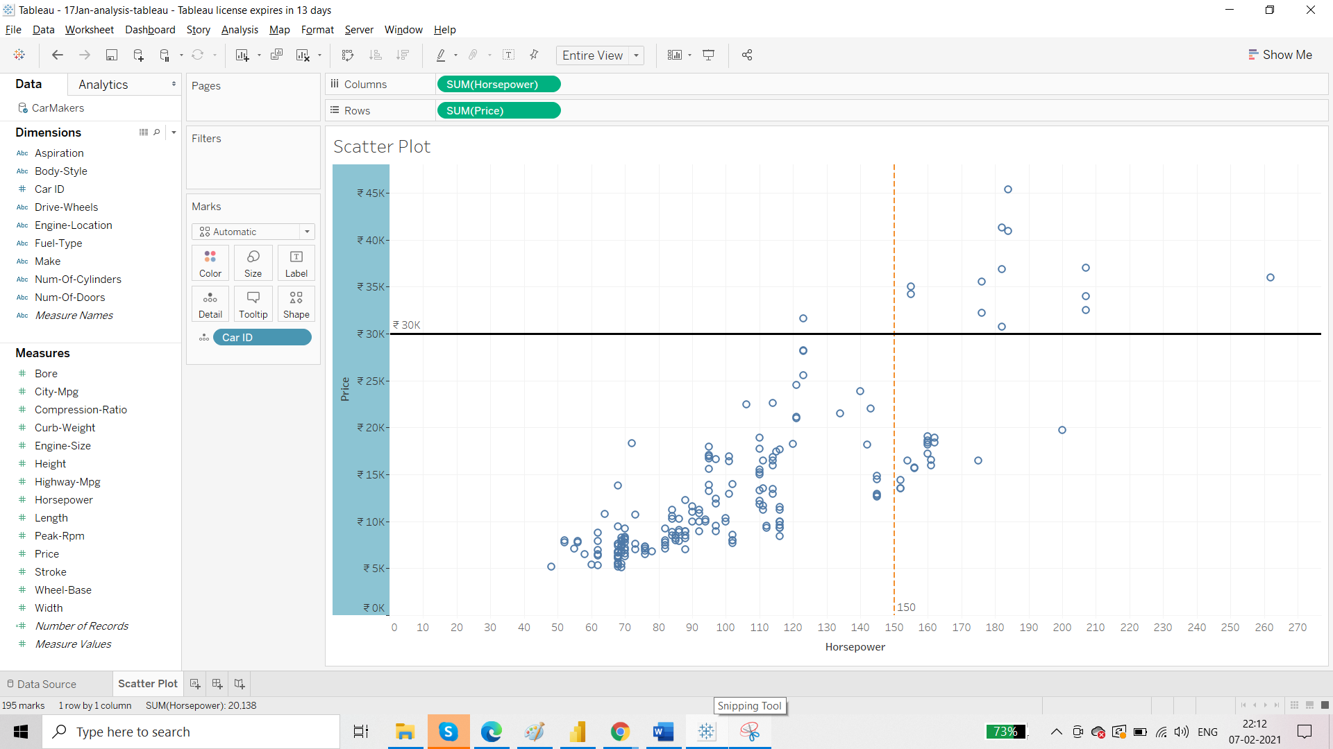

So, the bottom right part displays the car those have >150 horsepower and less than 30k price.

**Requirement 3: From these cars, we have to differentiate between petrol and diesel one.**

To achieve this, drag ‘Fuel-Type’ to color on the Marks card.

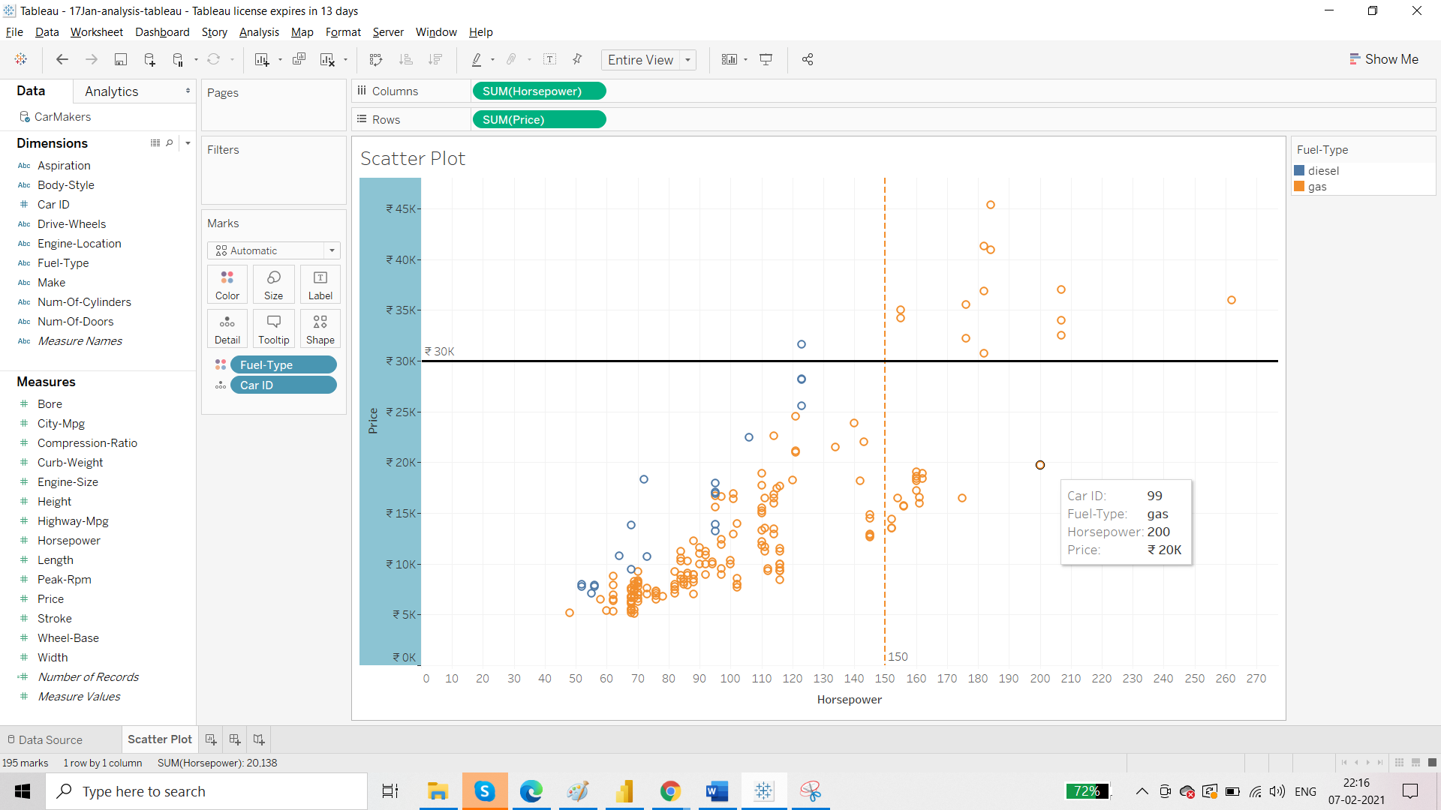

Requirement B: Distribution of length of a car in this dataset

Whenever we create a histogram using a measure then Tableau automatically creates a bin dimension.

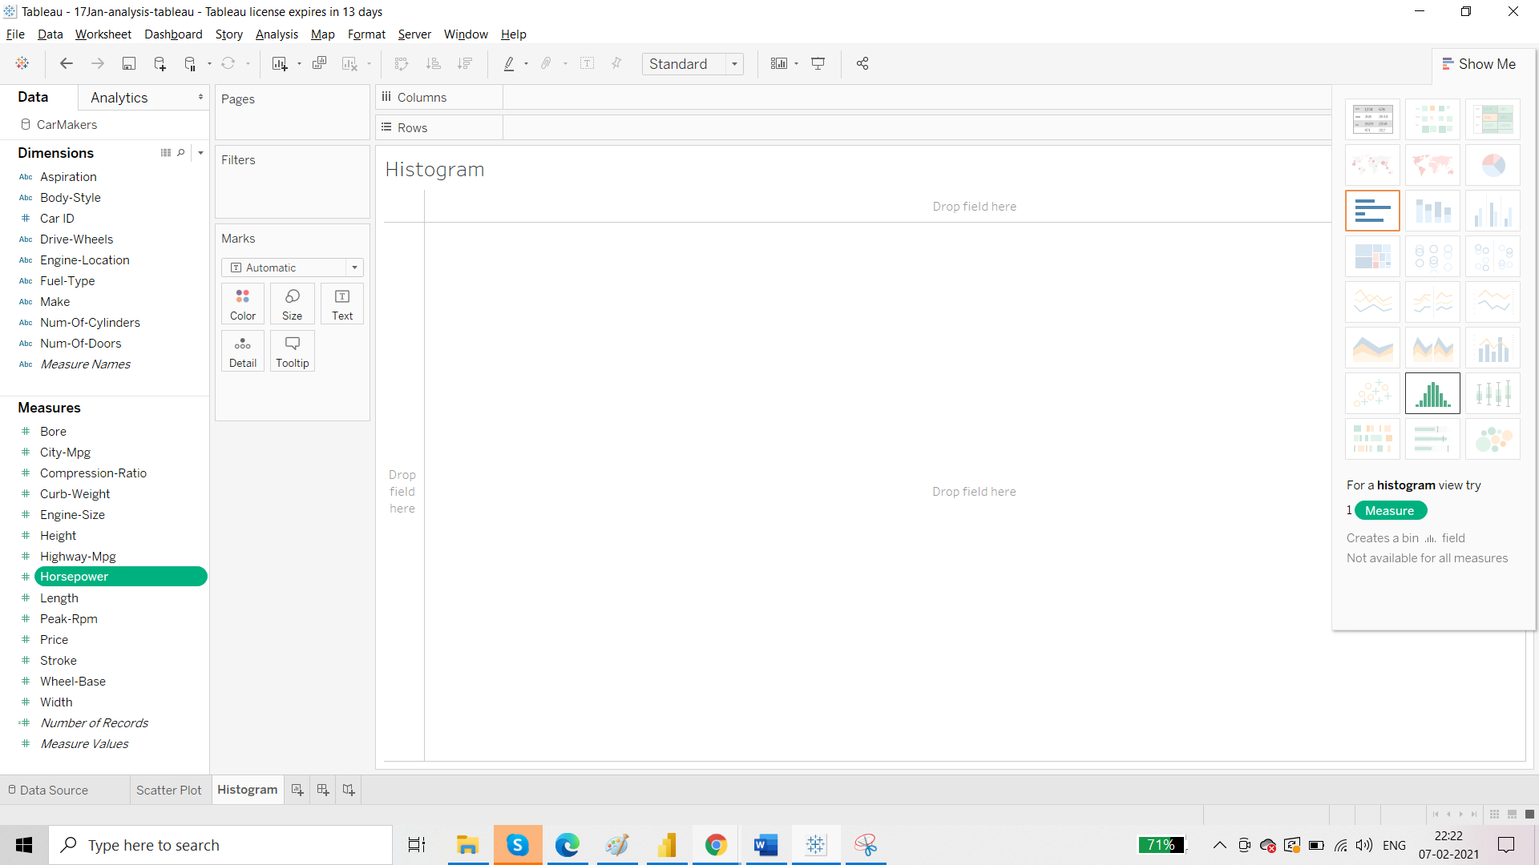

Make the histogram.

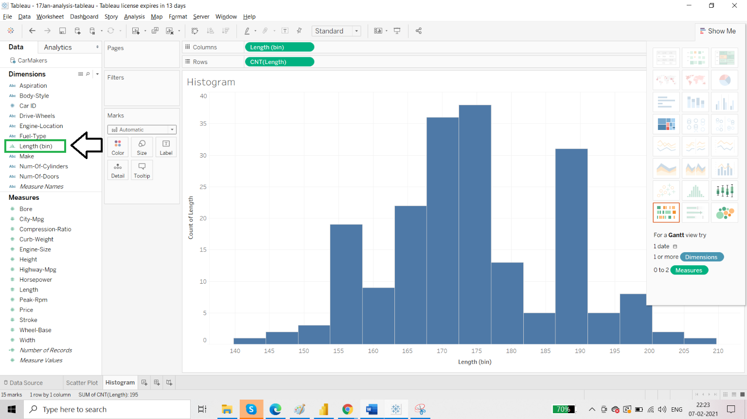

We can edit the size of the bin:

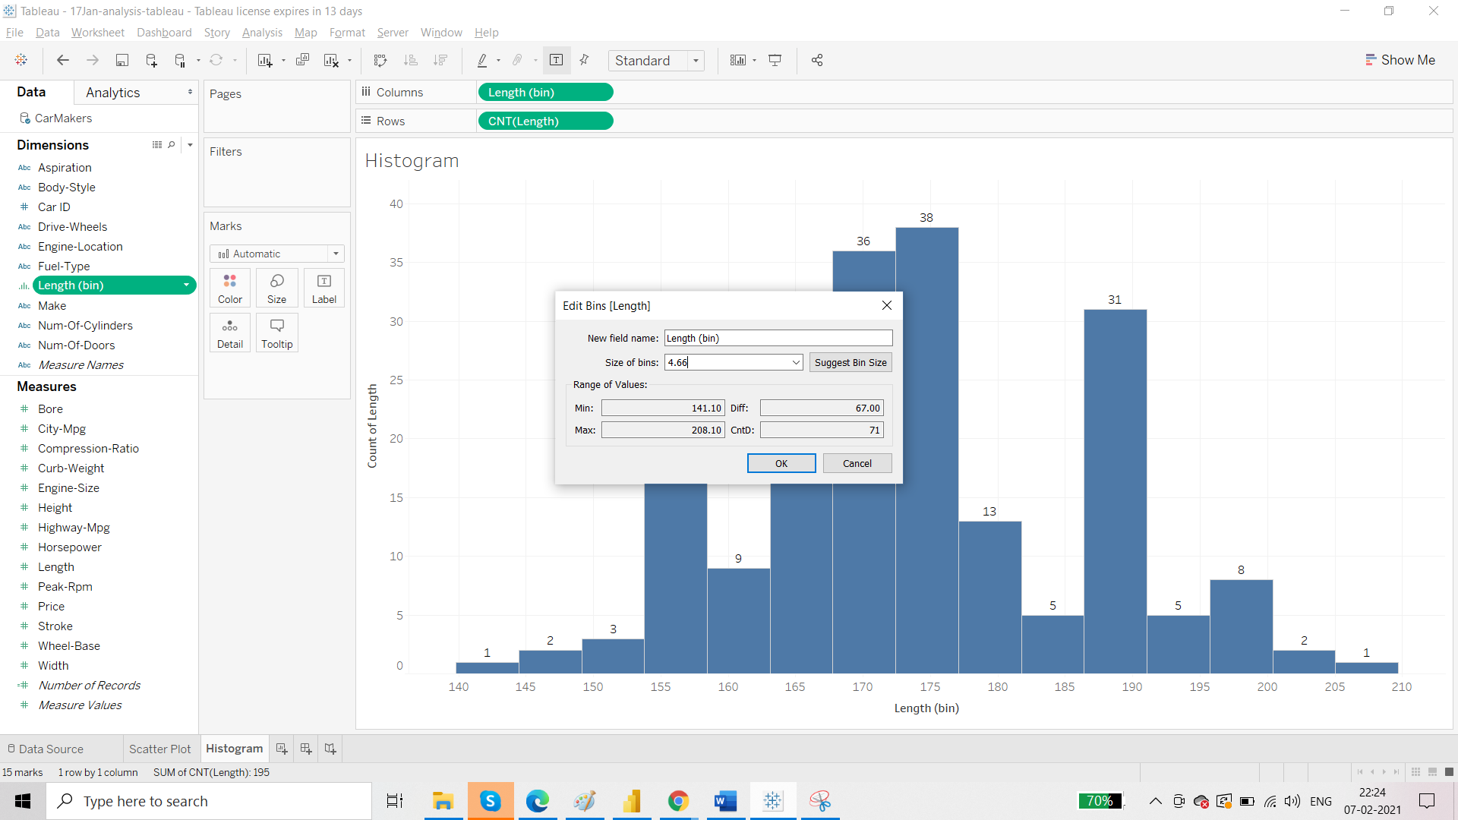

Make it as 10:

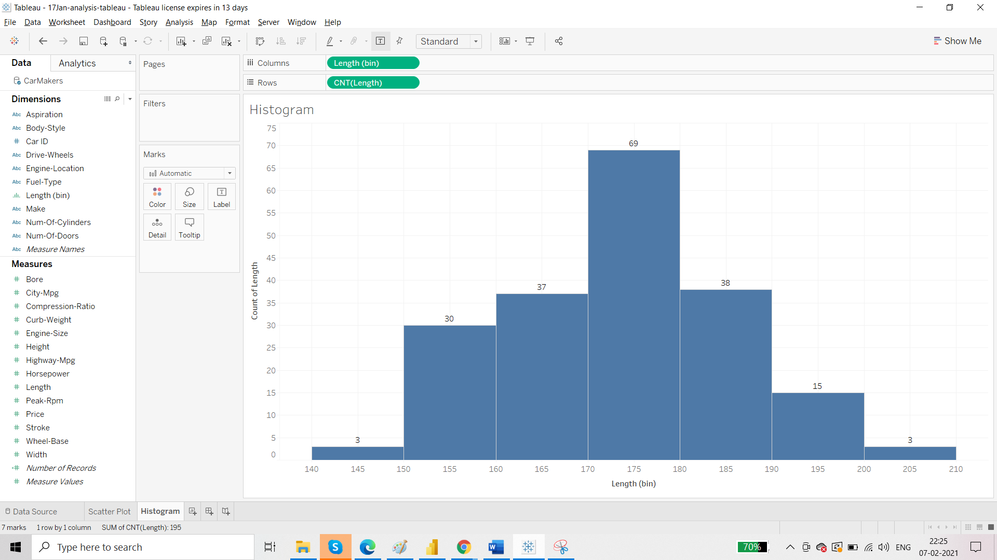

Requirement: we want to know Fuel type

Take the fuel type and release it over the colour on Marks Card

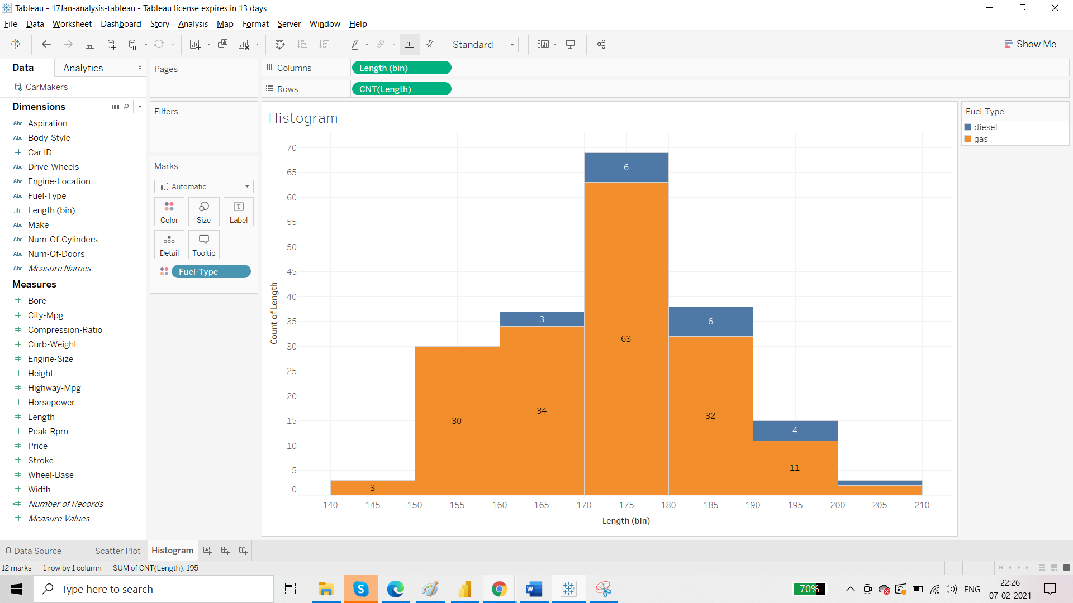

In the last range from 200 to 210, the labels are not visible because the labels are overlapping. So do the following change:

Check this box:

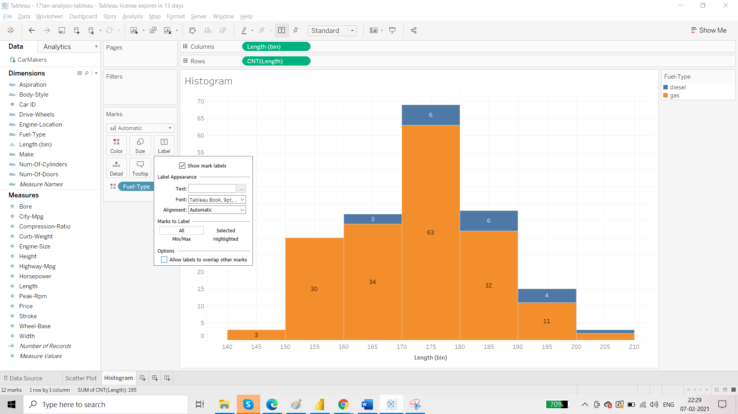

Result:

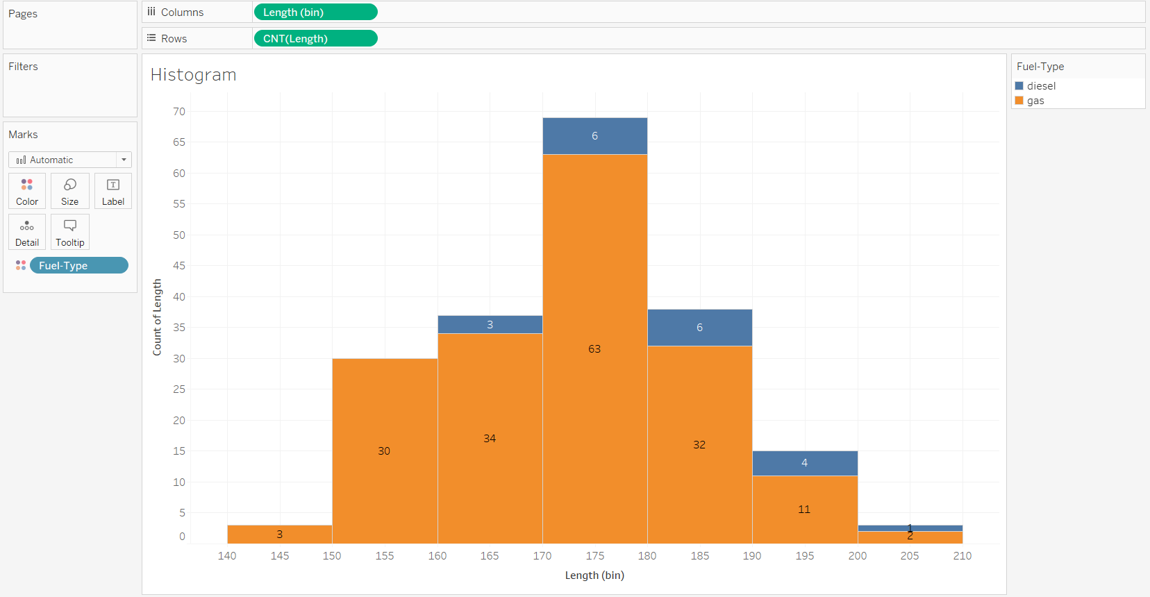

Requirement C: Number of cars manufactured under different body style and type of fuel

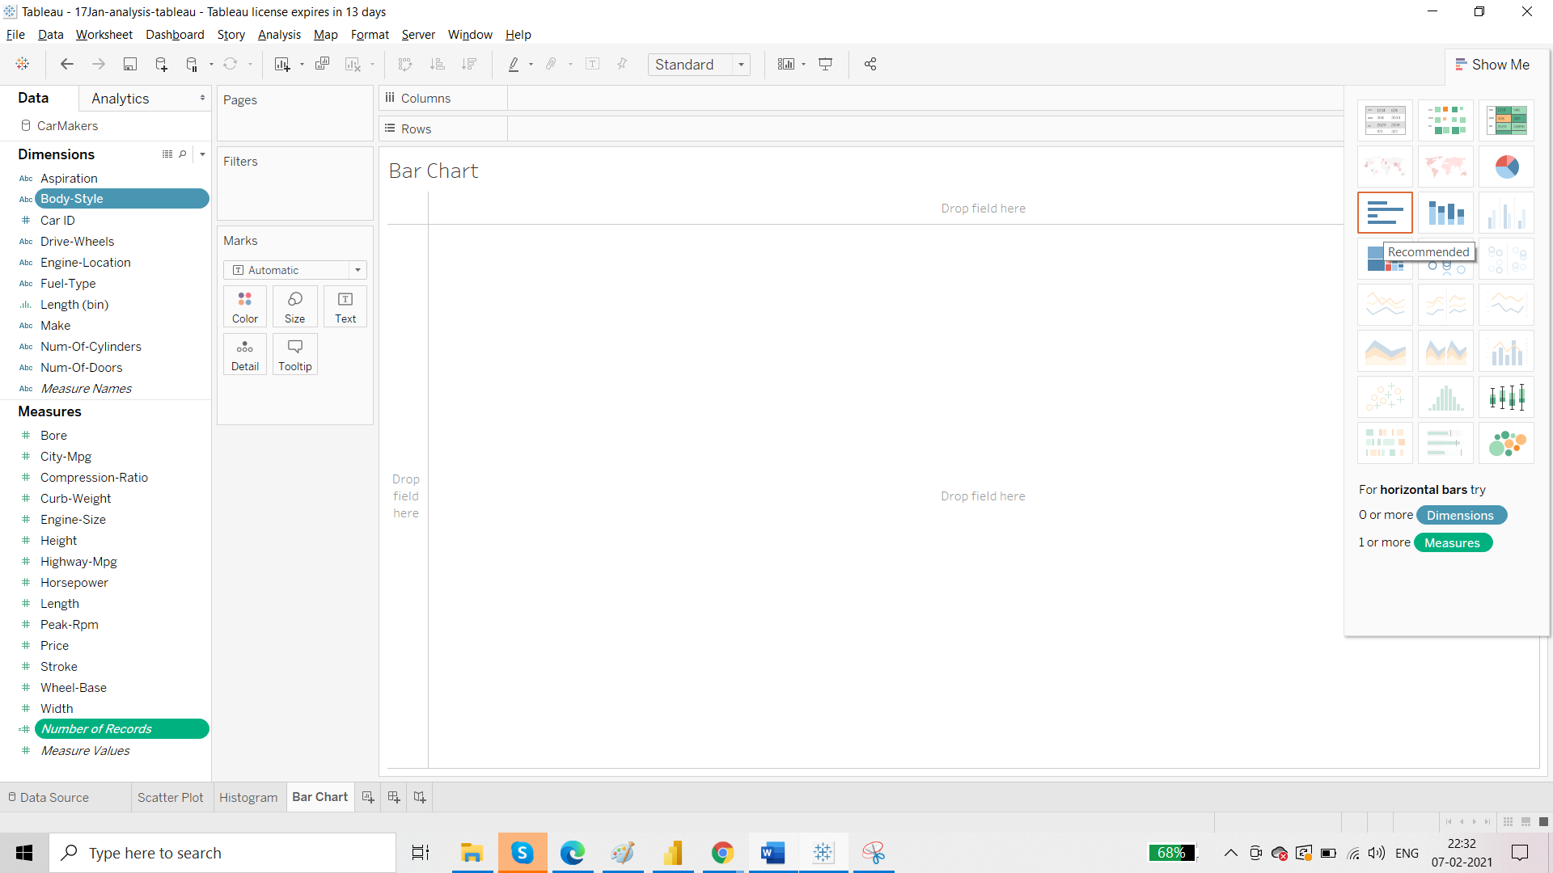

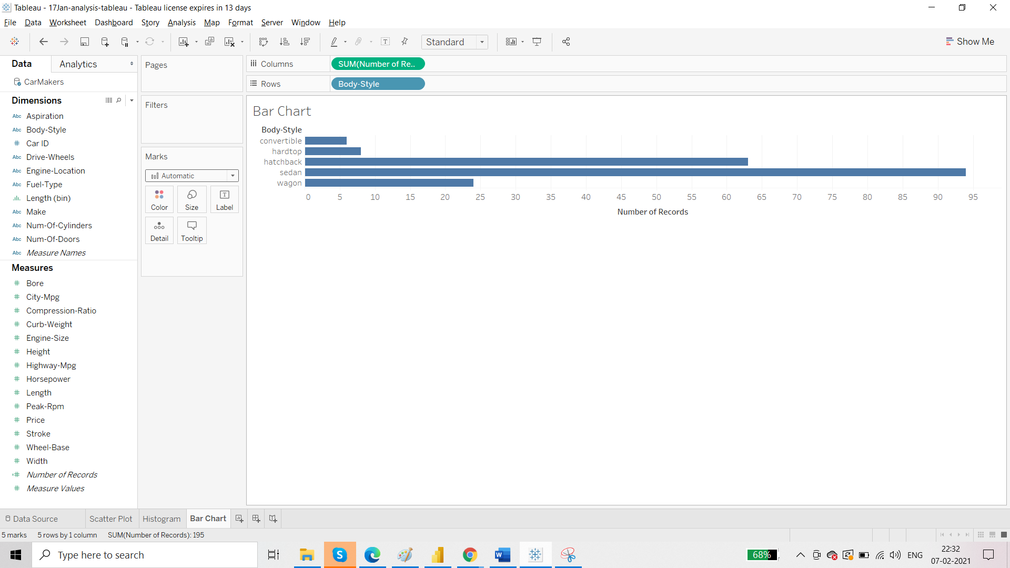

Doing the necessary formatting discussed above we get:

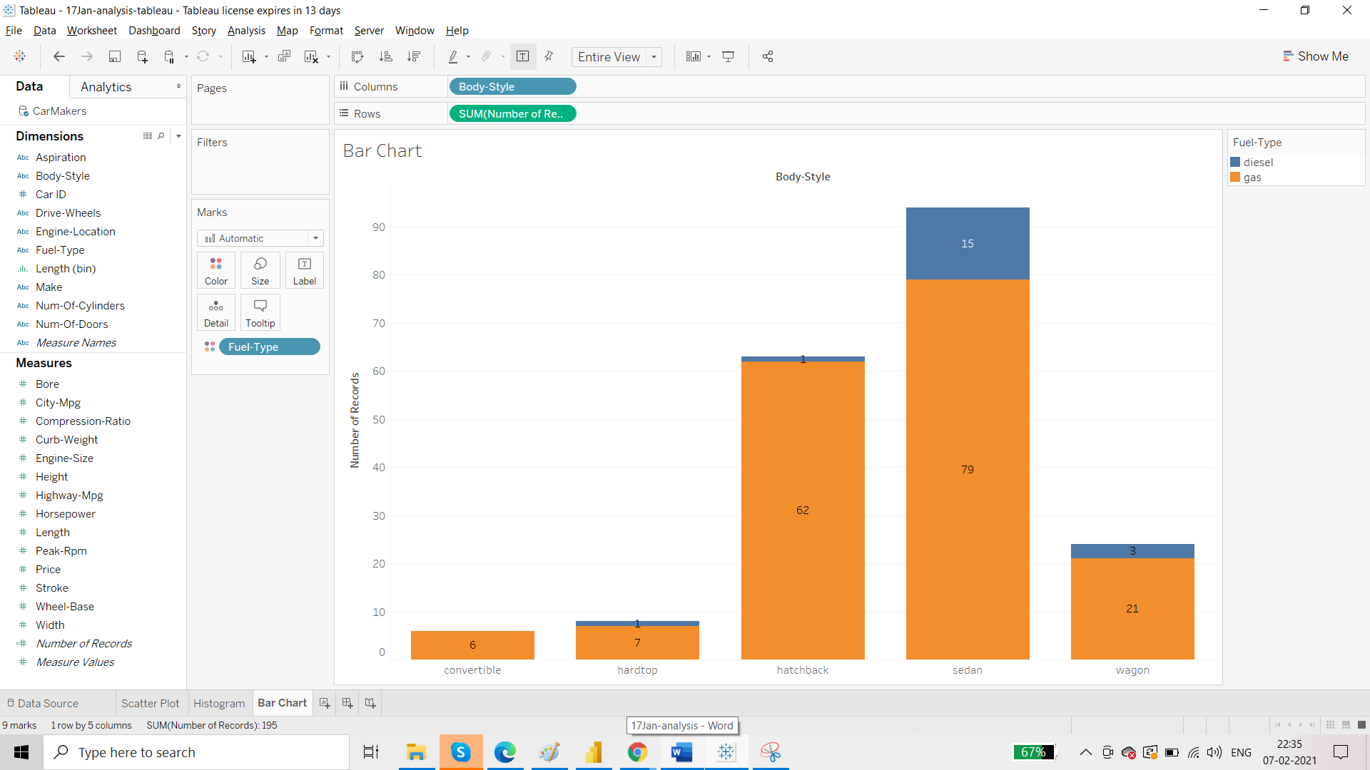

Requirement D: Number of cars as per fuel type

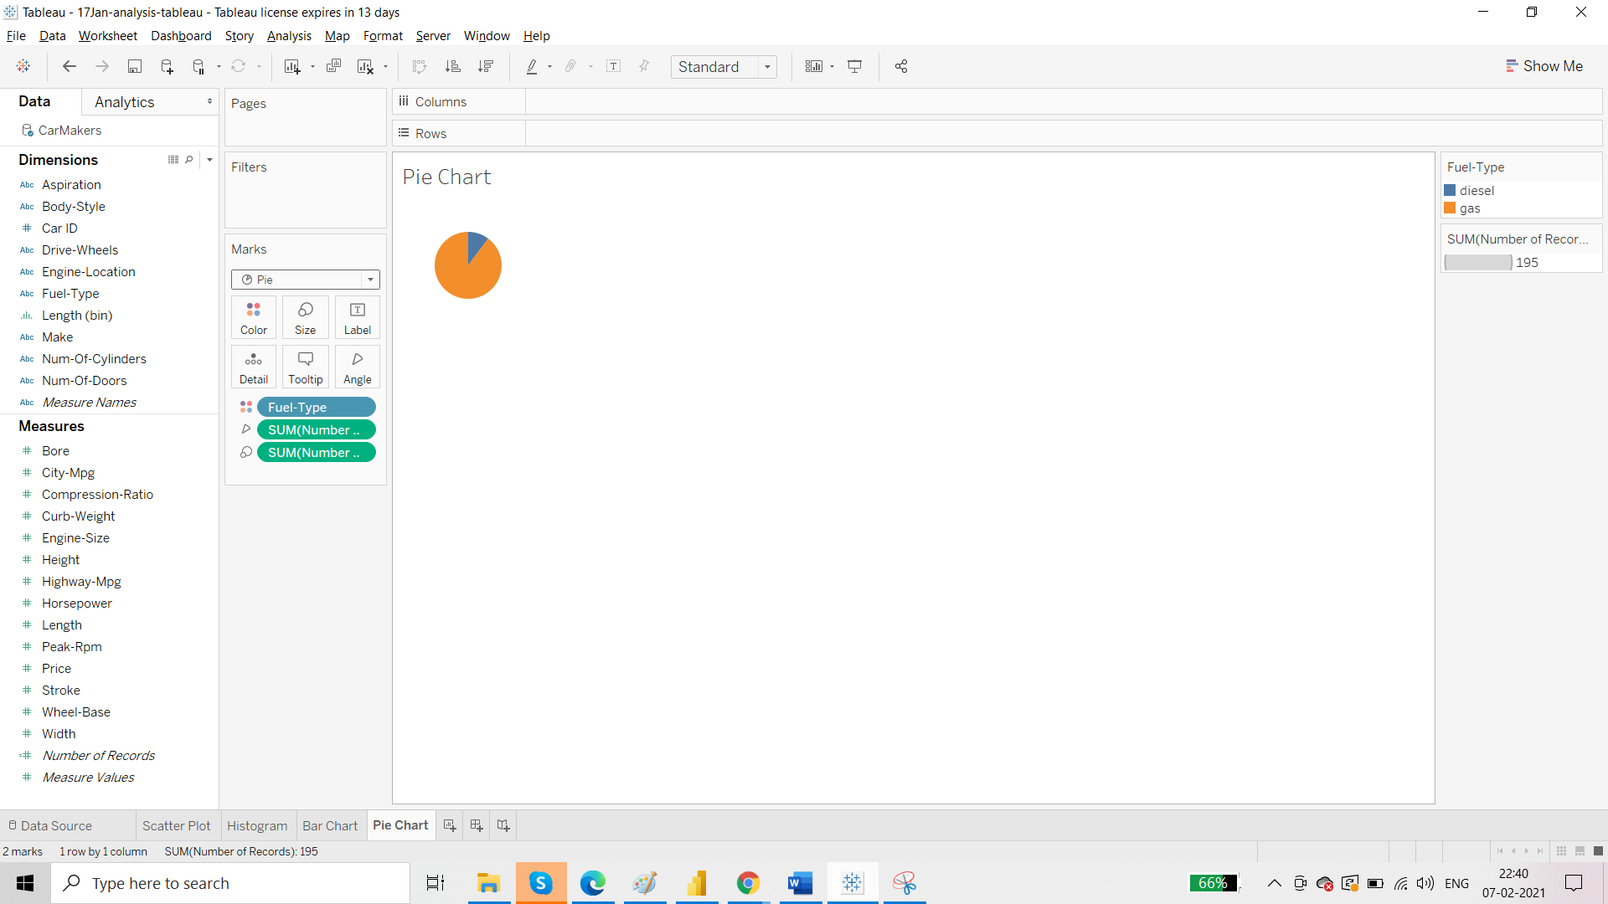

To Label this pie chart, bring Number of Records in Label:

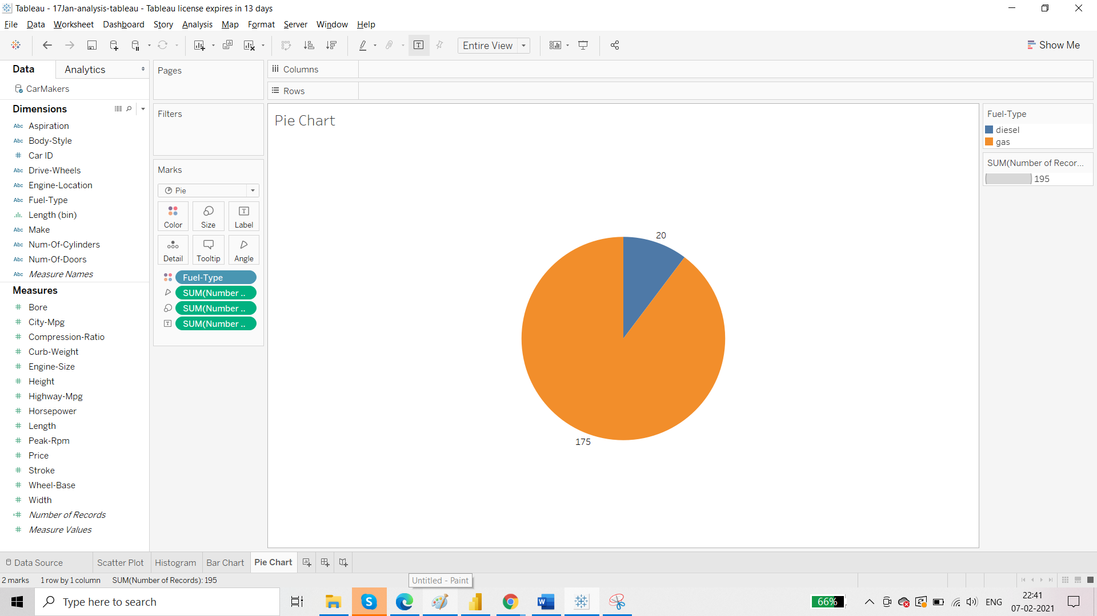

Rule for Pie Charts: Categories should be less than 5.

For categories more than 5 go for treemap.

Requirement E: Different Manufacturers

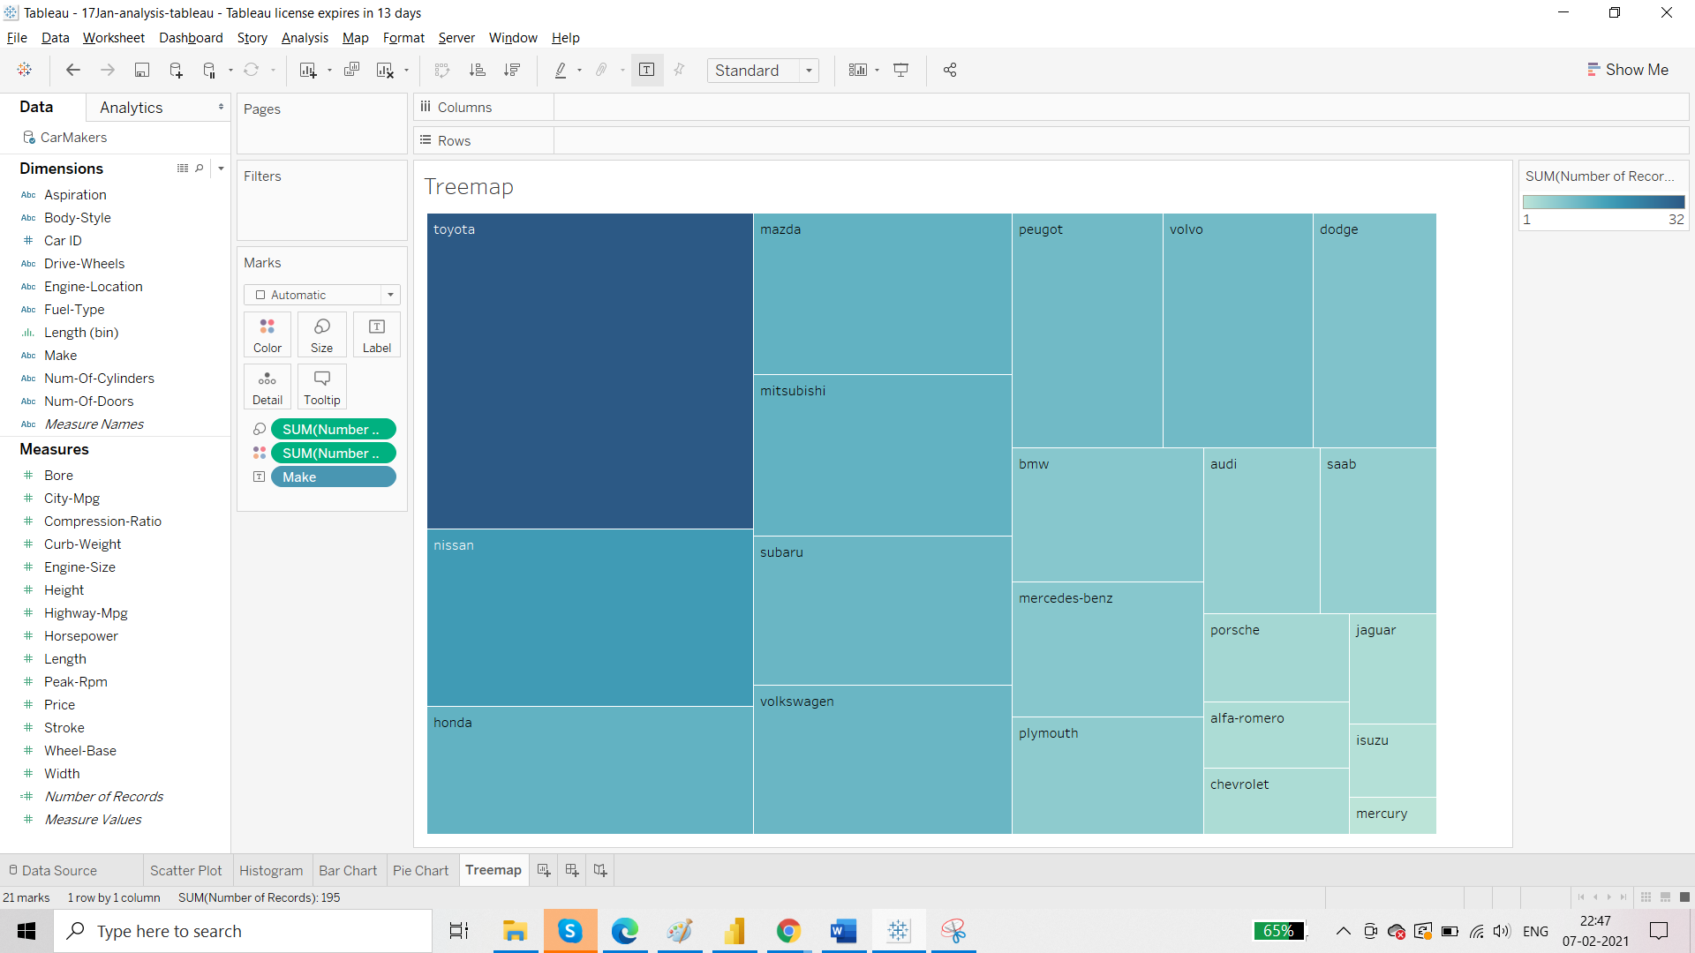

We can create Groups in the treemap:

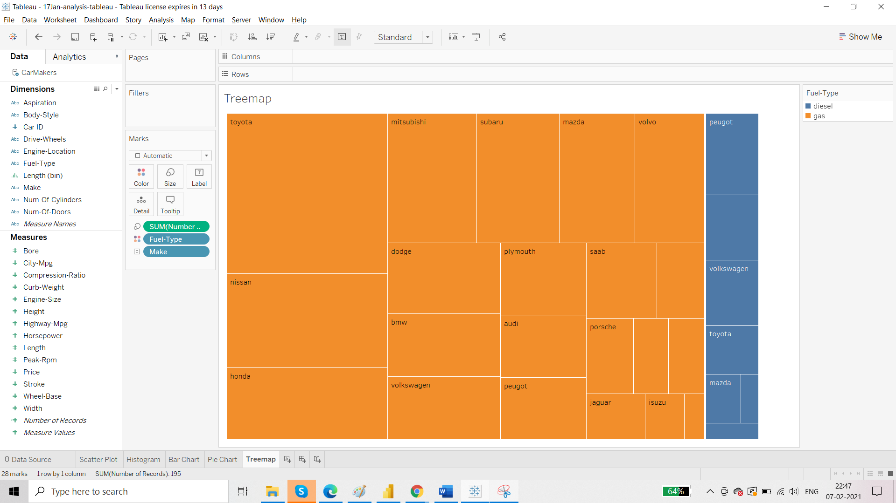

For tree map the size card does not work.

Requirement F: Different Manufacturers in terms of wordcloud

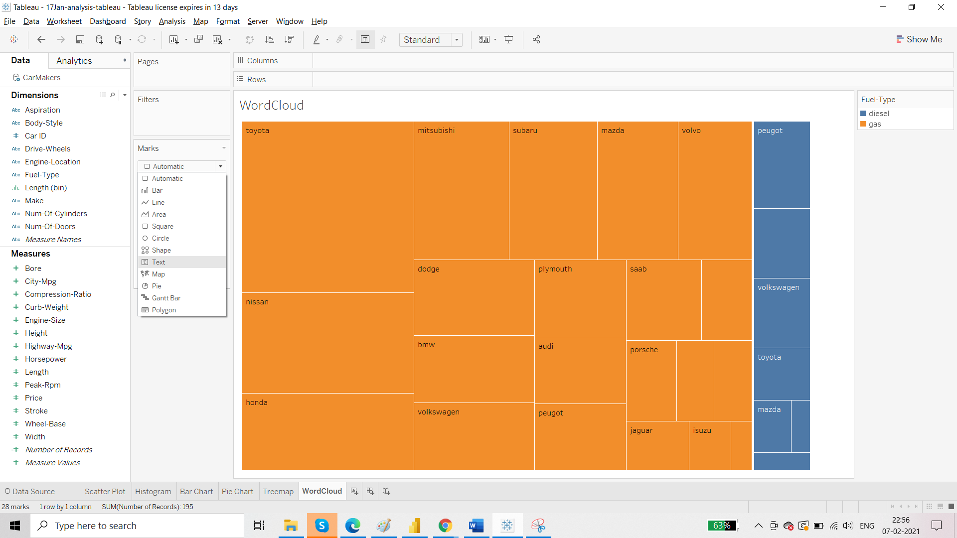

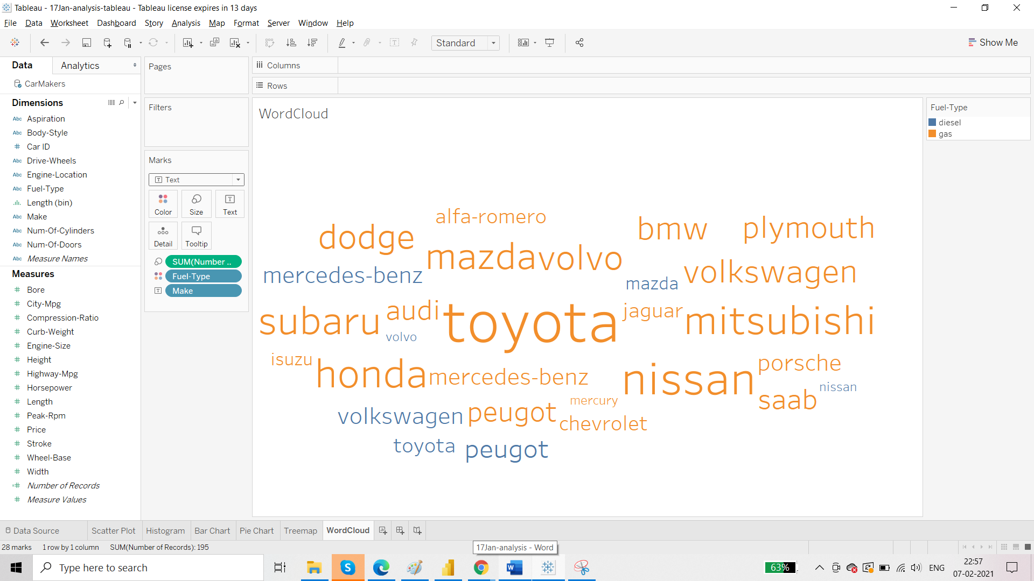

Requirement G: Donut chart

Duplicate the Pie chart worksheet and rename it as Donut Chart

Bring ‘Number of Records’ to Rows shelf:

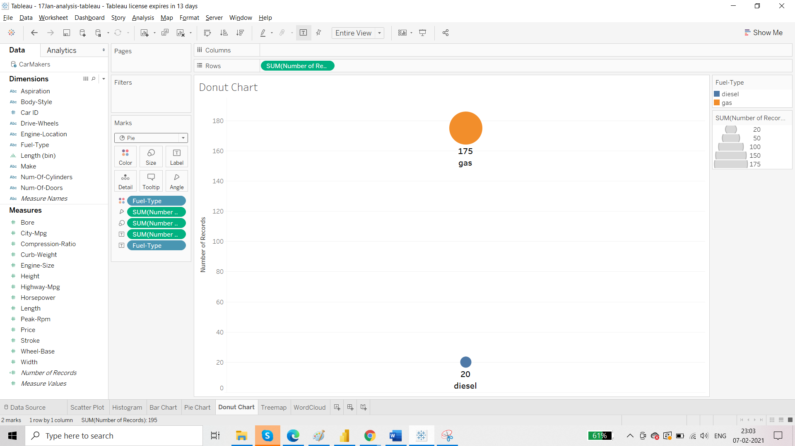

Now we will be using the concept of aggregation to combine these two.

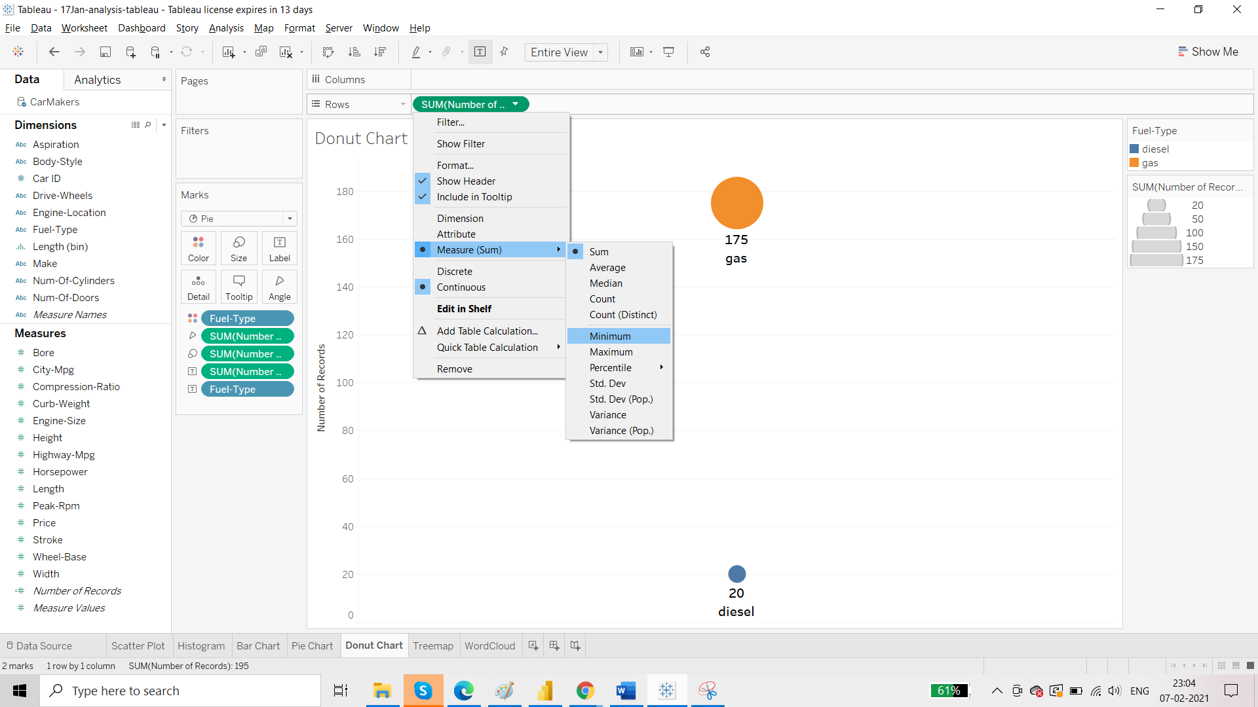

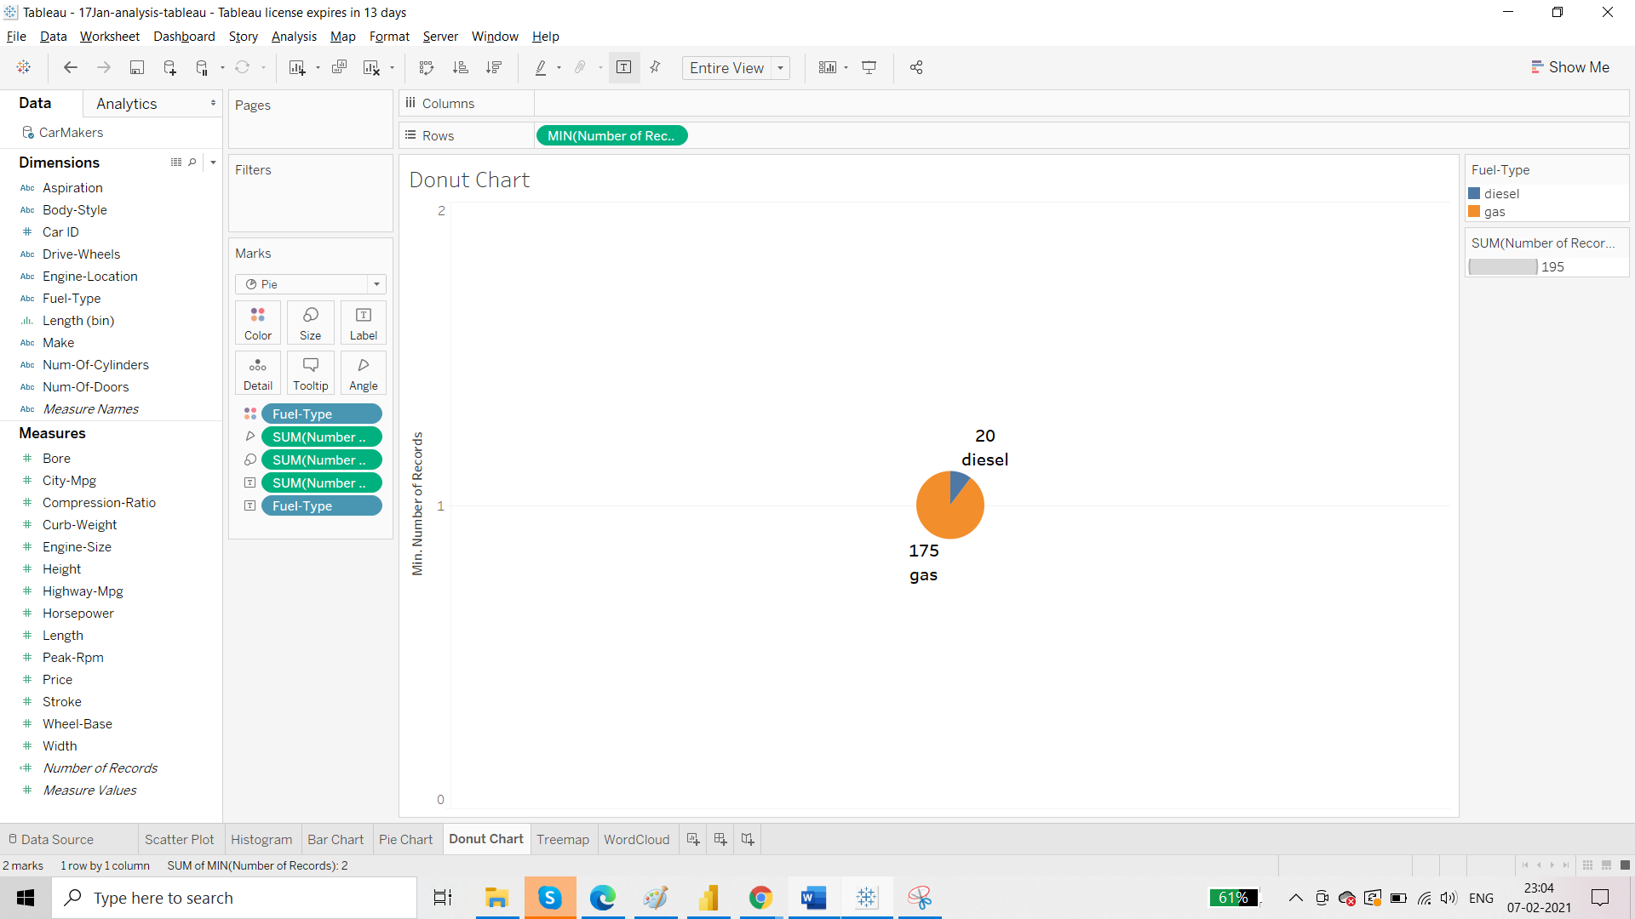

Copy the pill on which you have performed the aggregation:

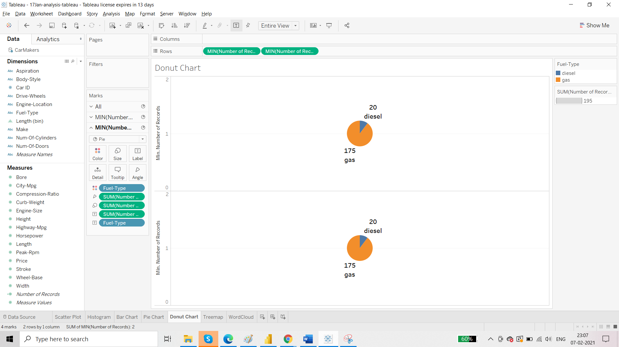

To create the donut chart, we have to combine these two. We use the concept of dual axis.

*Dual Axis is always applicable in second pill.

Before applying Dual Axis, remove the pills from the Marks card for the second aggregation

Apply Dual Axis

Resize the charts

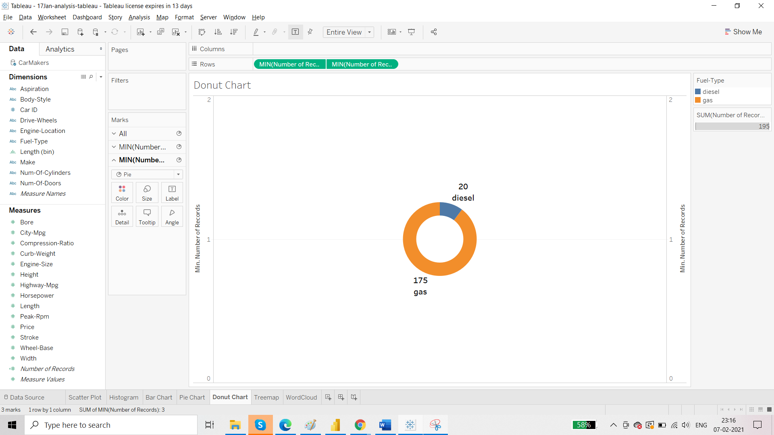

Whenever we create Bar Chart, the total from the top is getting removed. That can be rectified using dual axis.

Duplicate the bar chart sheet

Add ‘Number of Records’ to rows and convert the second bar chart to line chart

Then apply dual axis.

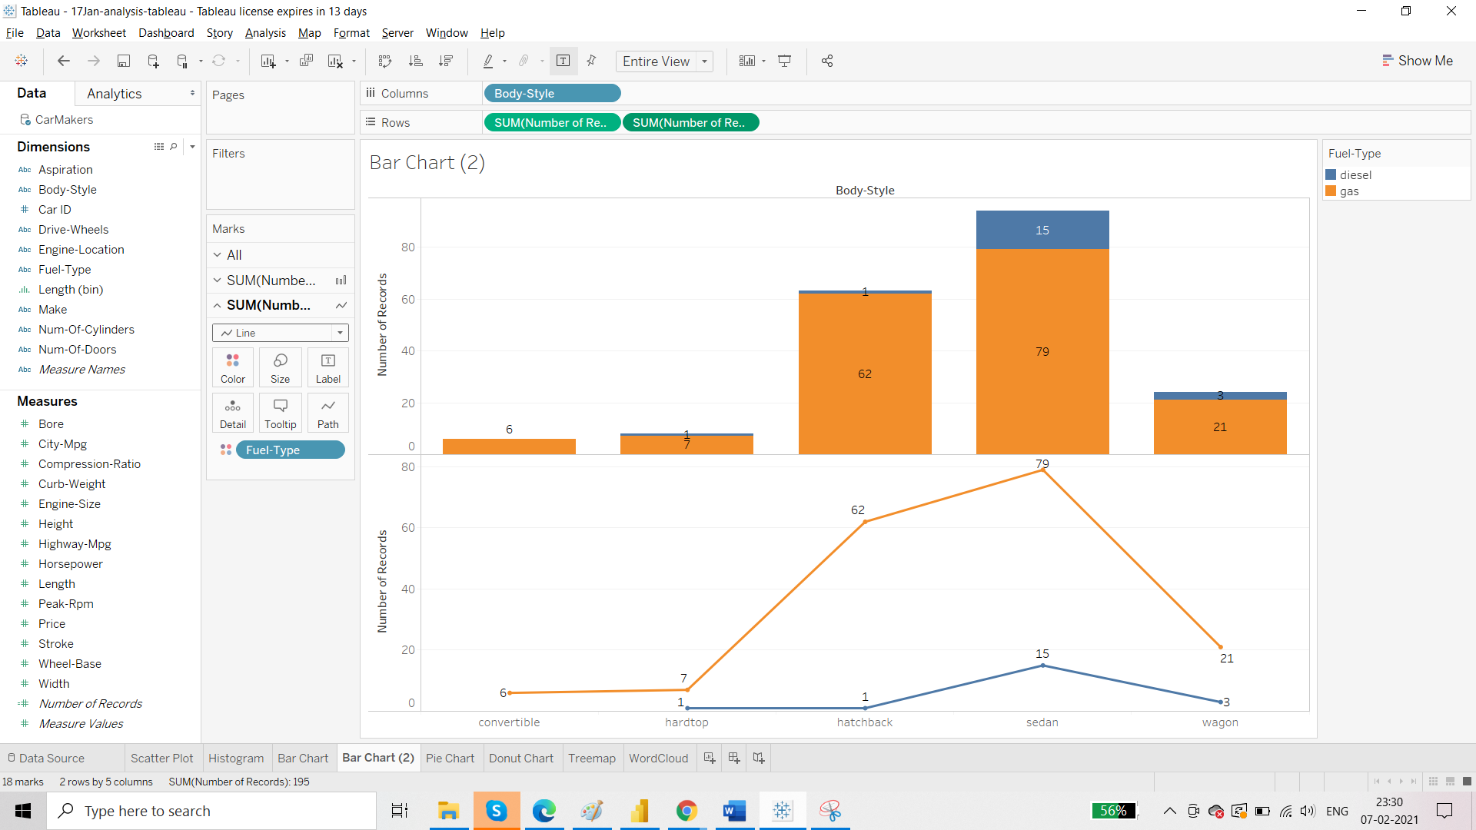

Remove the ‘Fuel Type’

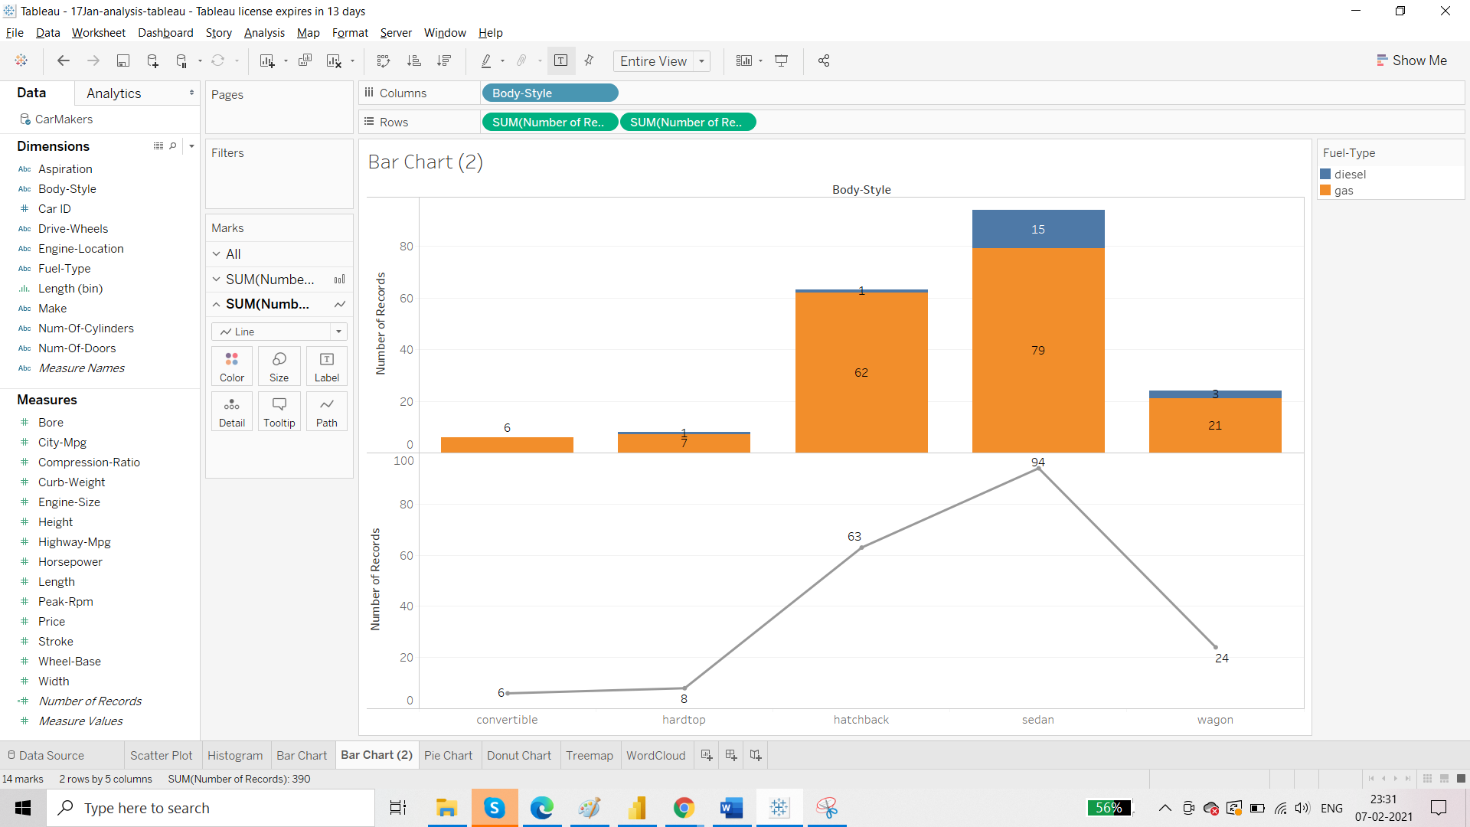

Alignment : Top center

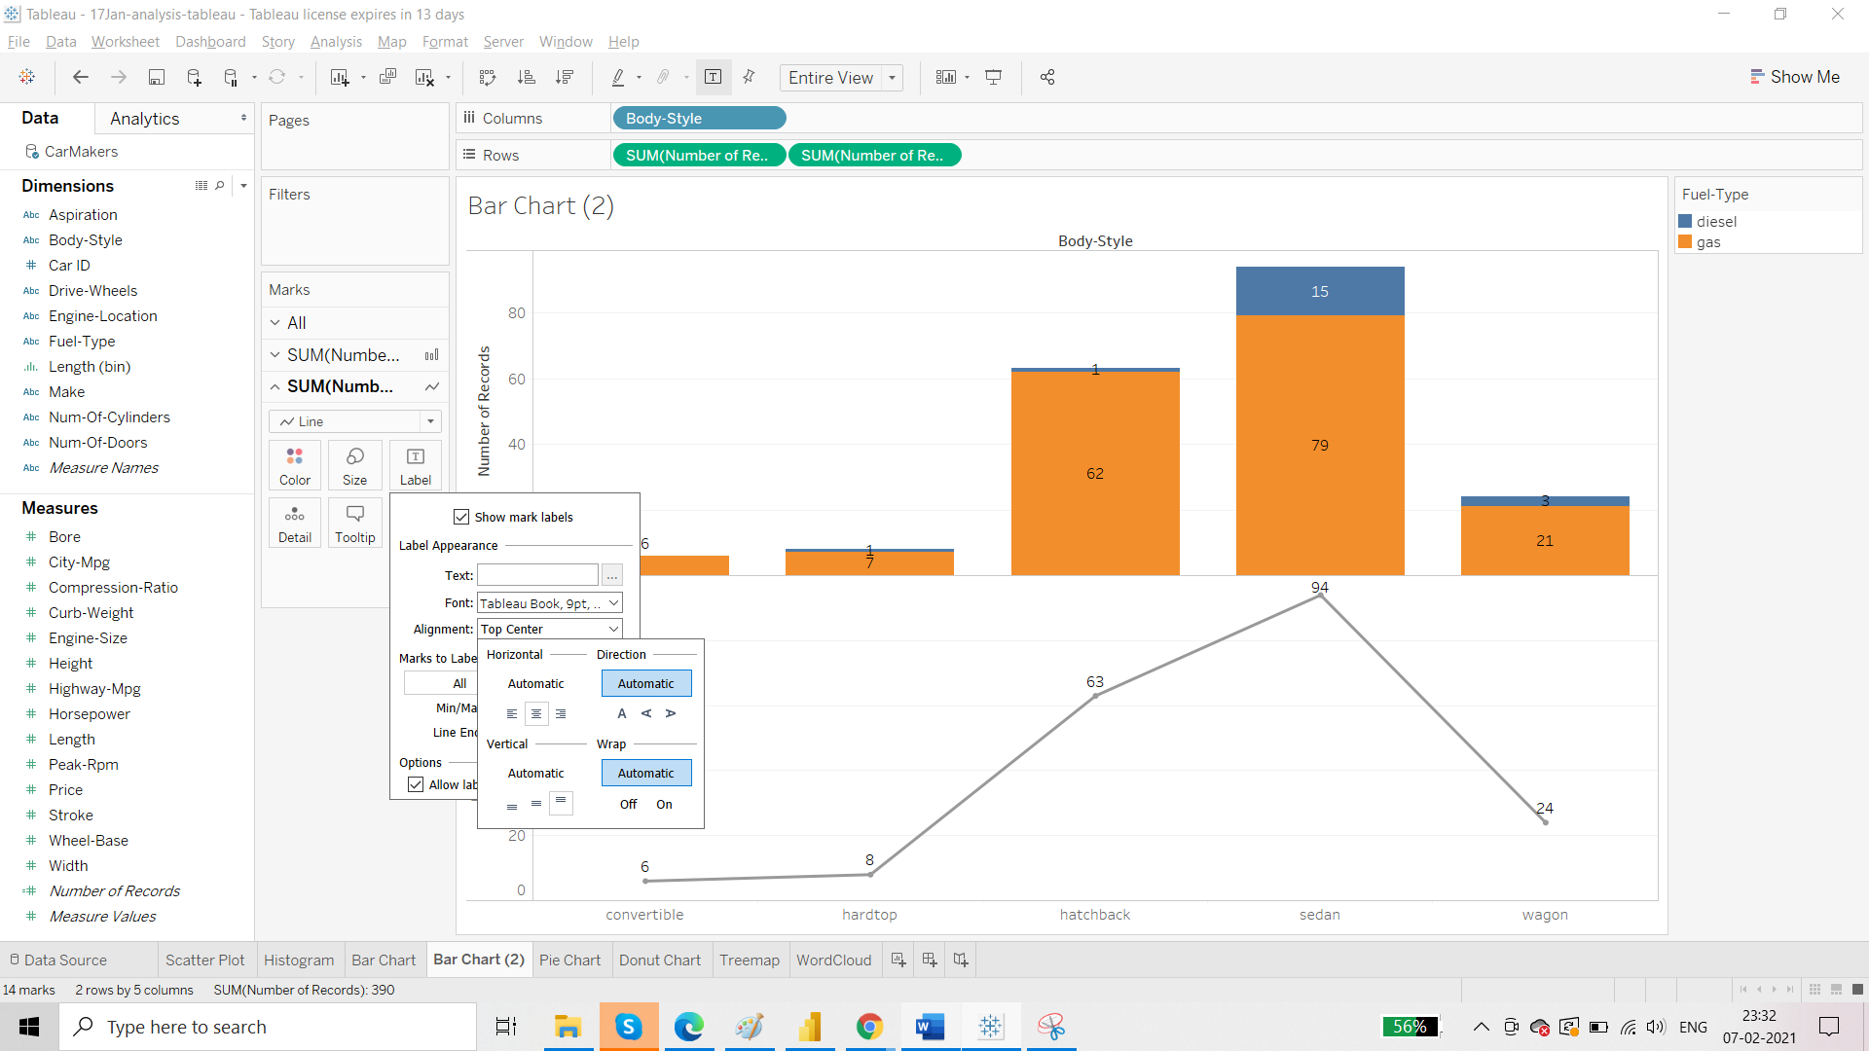

Click on Dual Axis

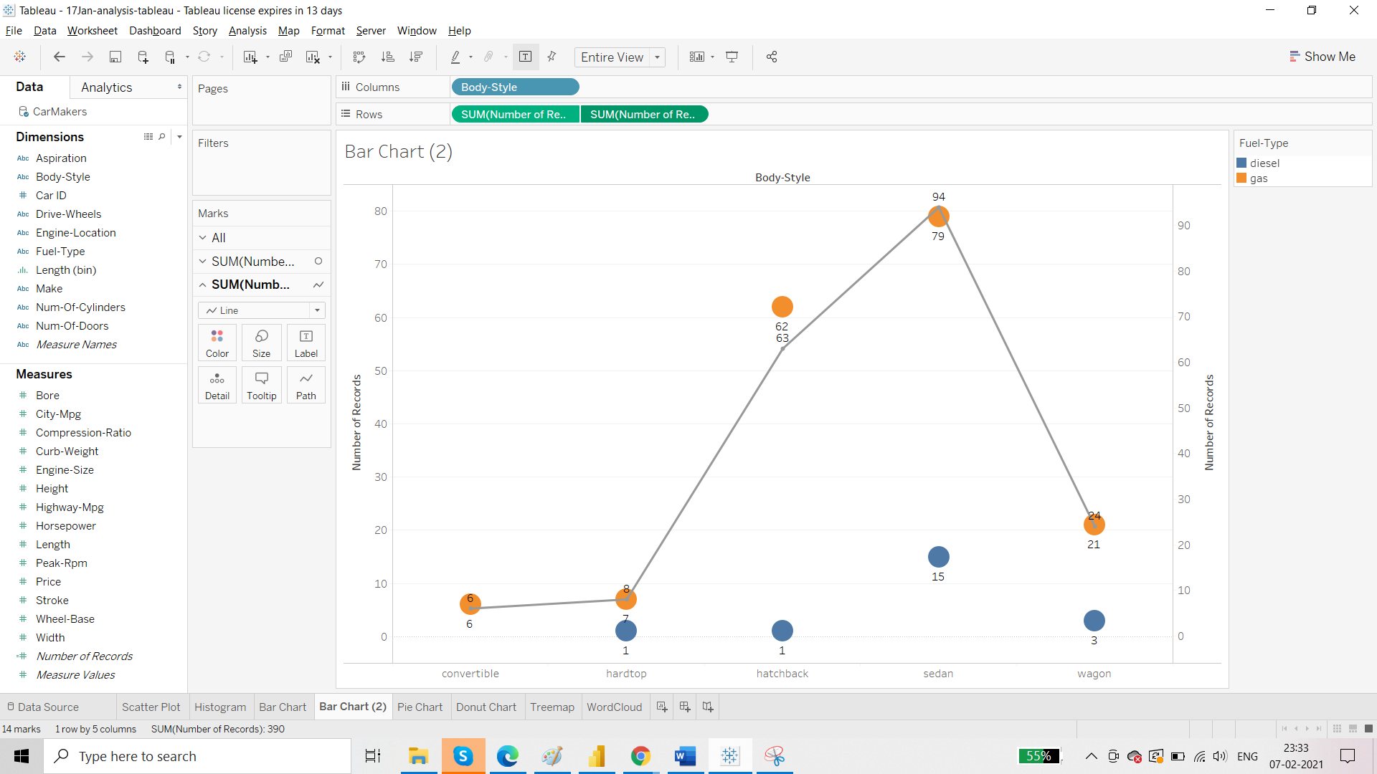

Convert the automatic into bar:

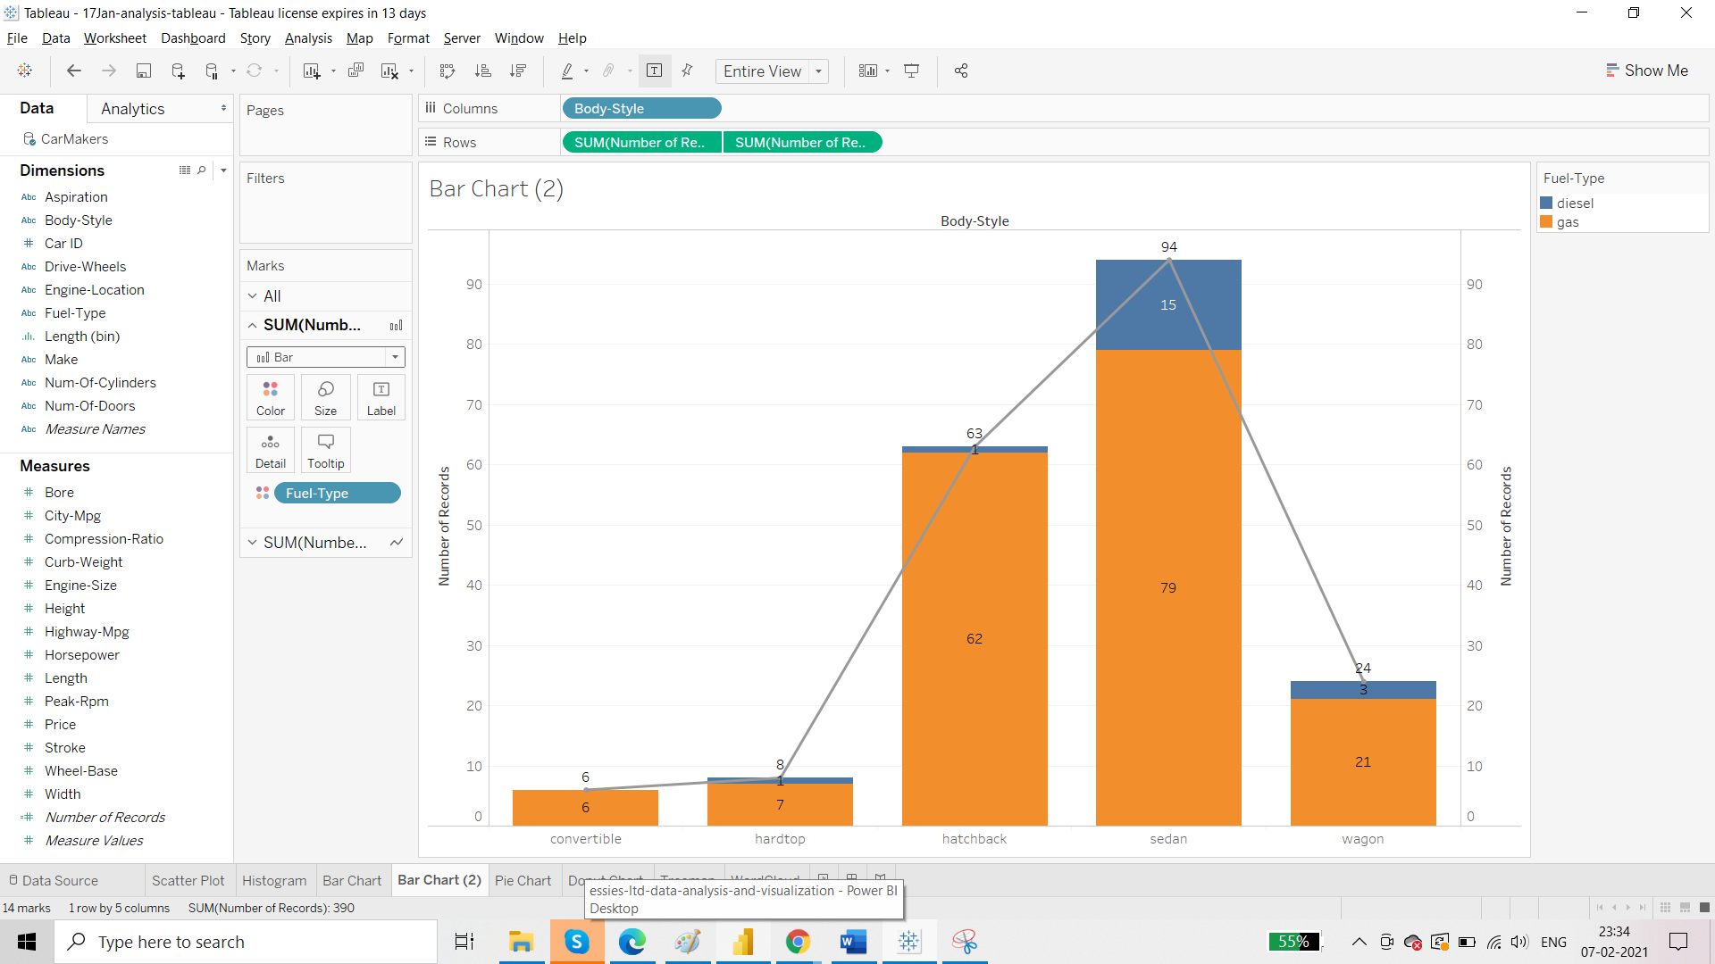

We can remove the line. From the second pill, set the transparency to 0% from colour card

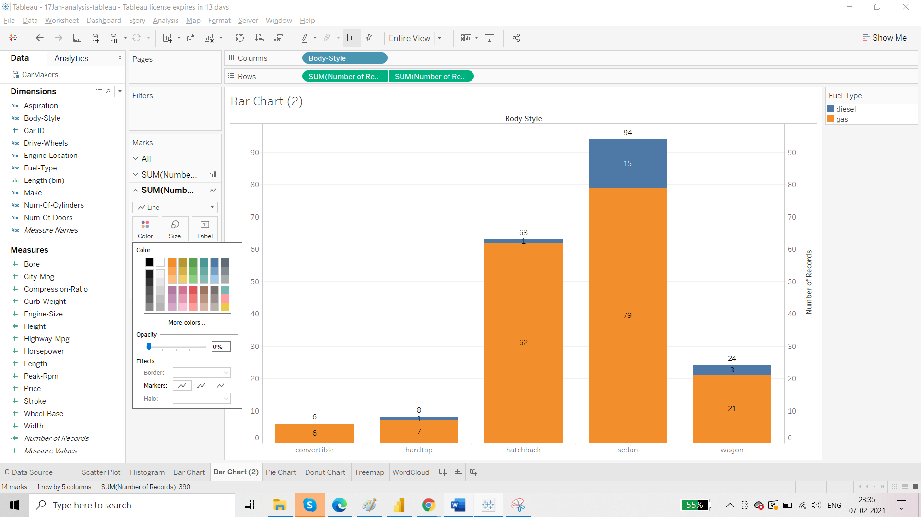

Requirement H: Line chart

Connect source: BirthRatio

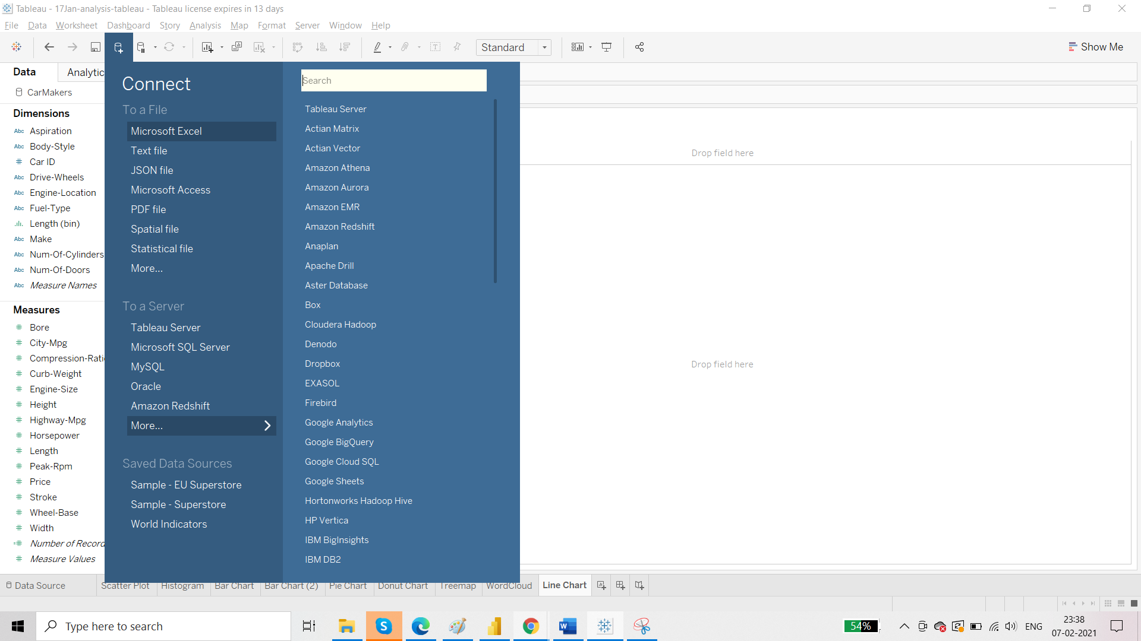

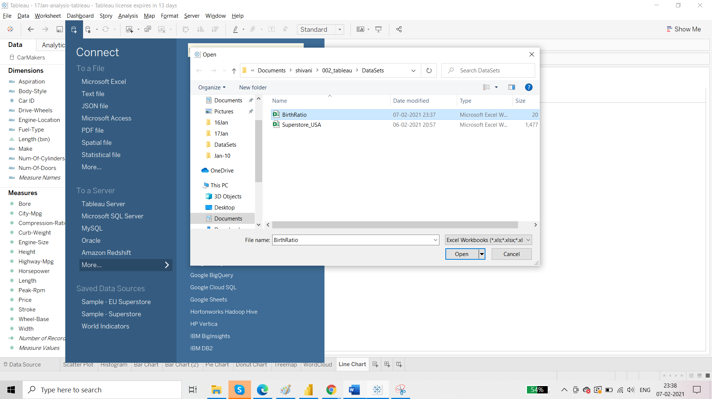

There are two kinds of values that we deal with in case of line charts:

* Discrete values: have a definite state of value. For example- number of people who can pass through a door. At a time, there will be fixed number of people who can pass through the door. They can be 6/7/8 not 4.5.
* Continuous values: temp, age, height

Discrete:

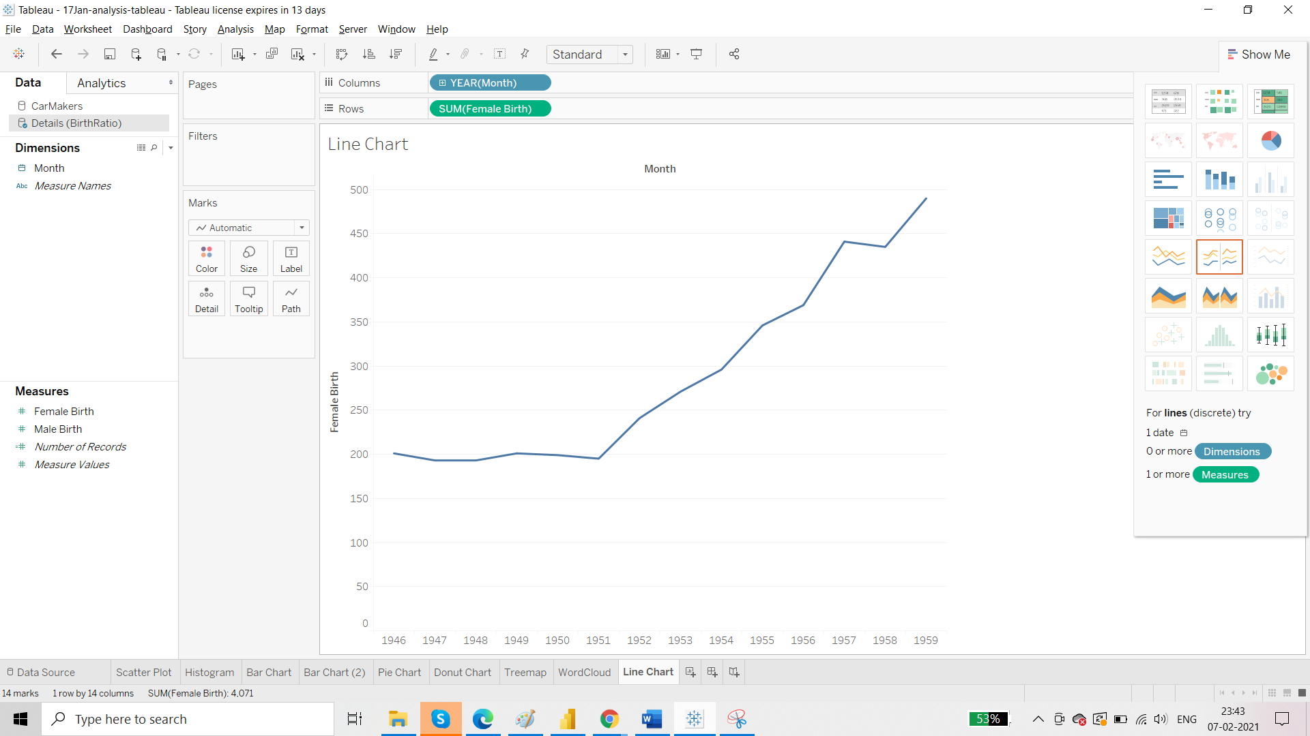

There is default hierarchy associated with date.

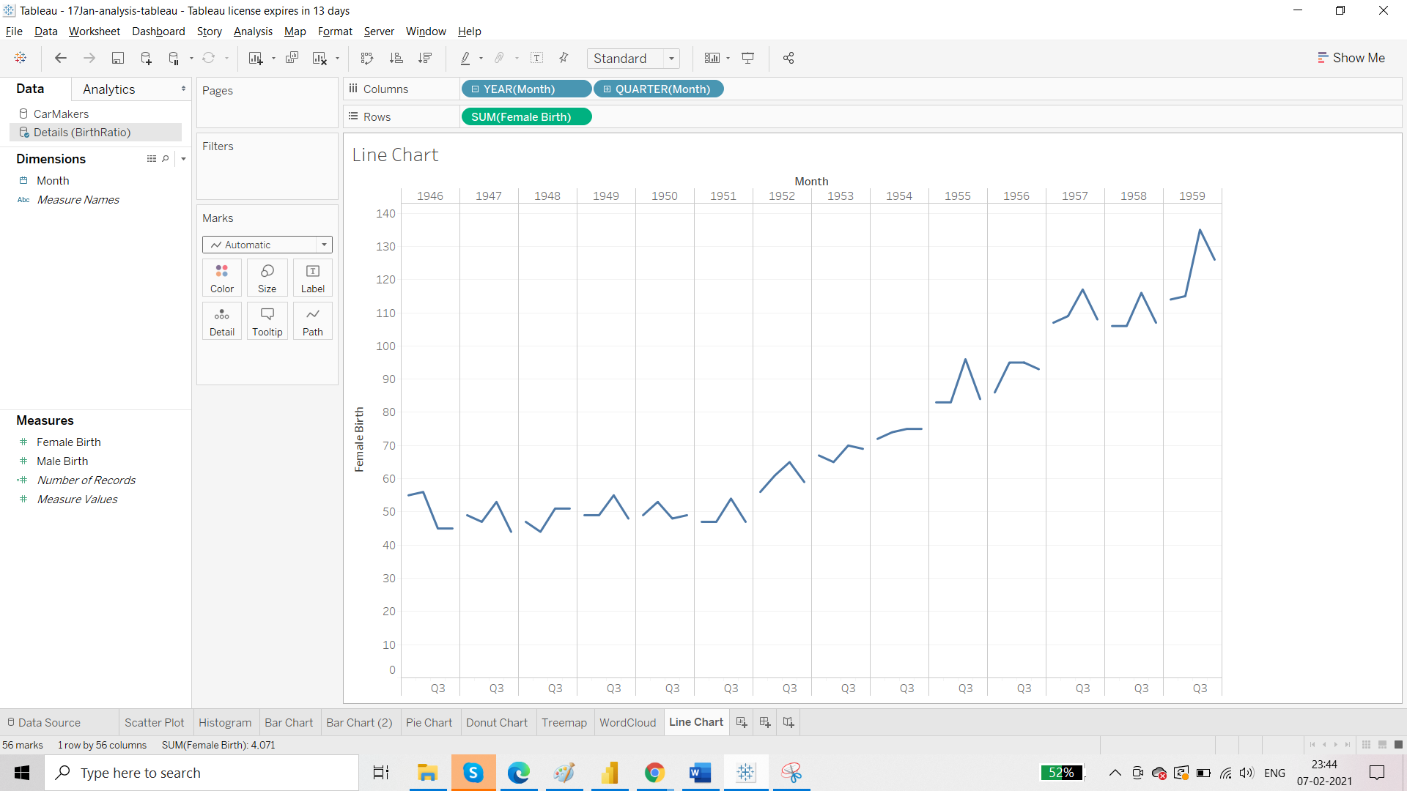

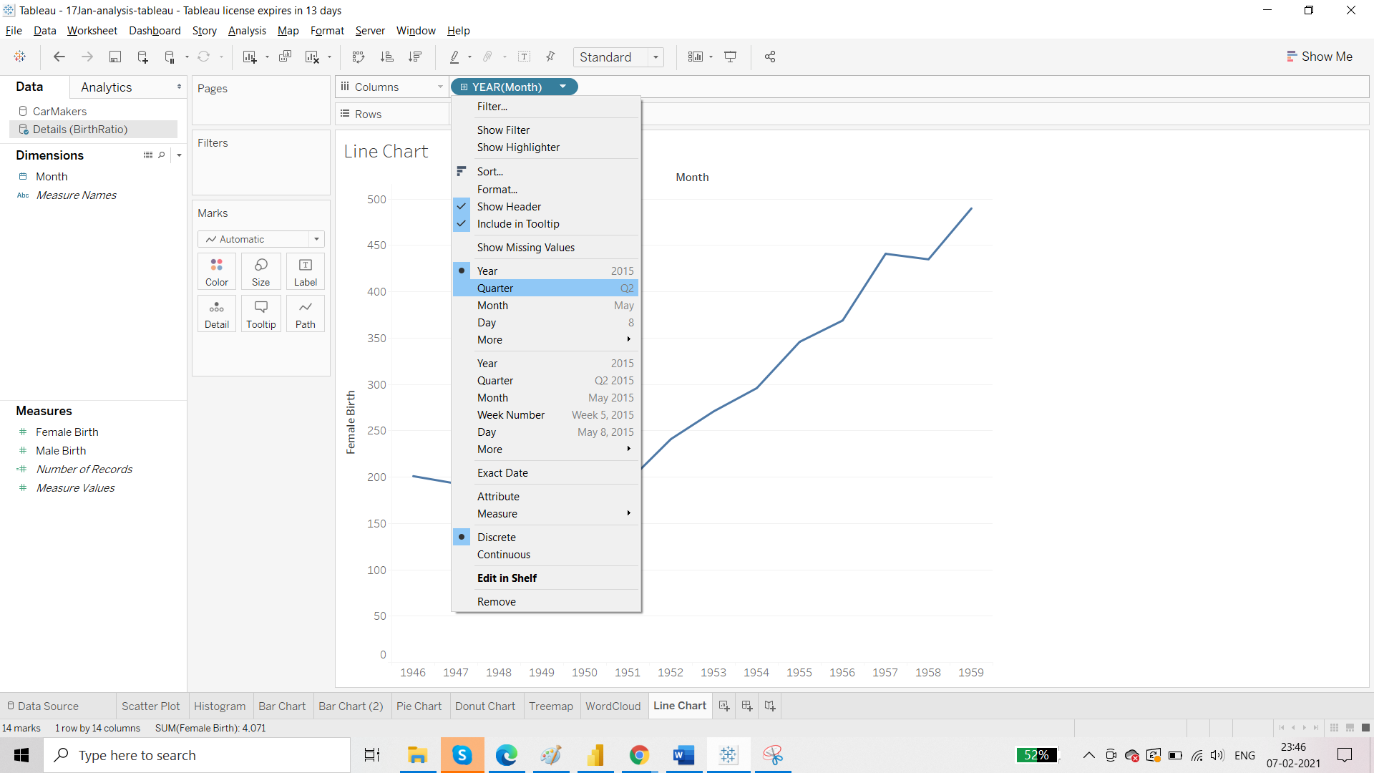

Upper hierarchy is Discrete and below is Continuous. So when you select Quarter from upper one, values for all the Quarters (1/2/3/4) will be summed and showed:

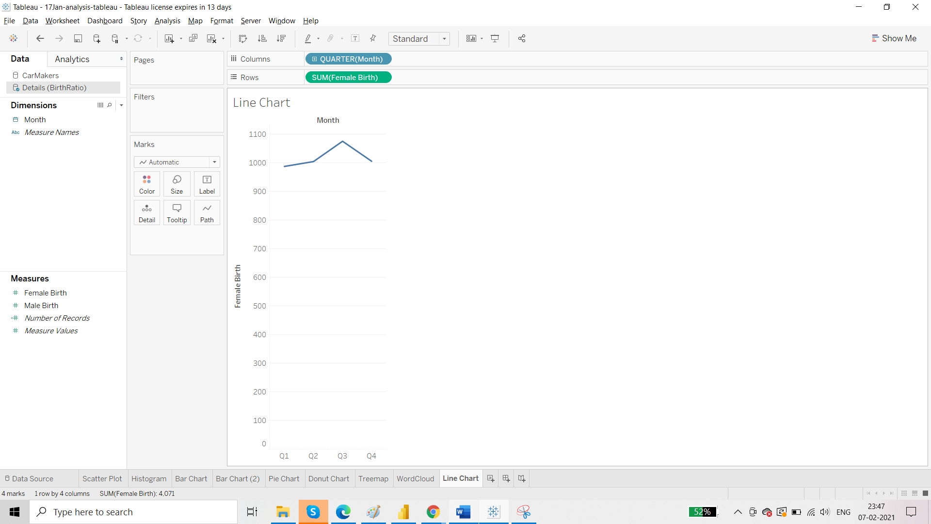

For continuous:

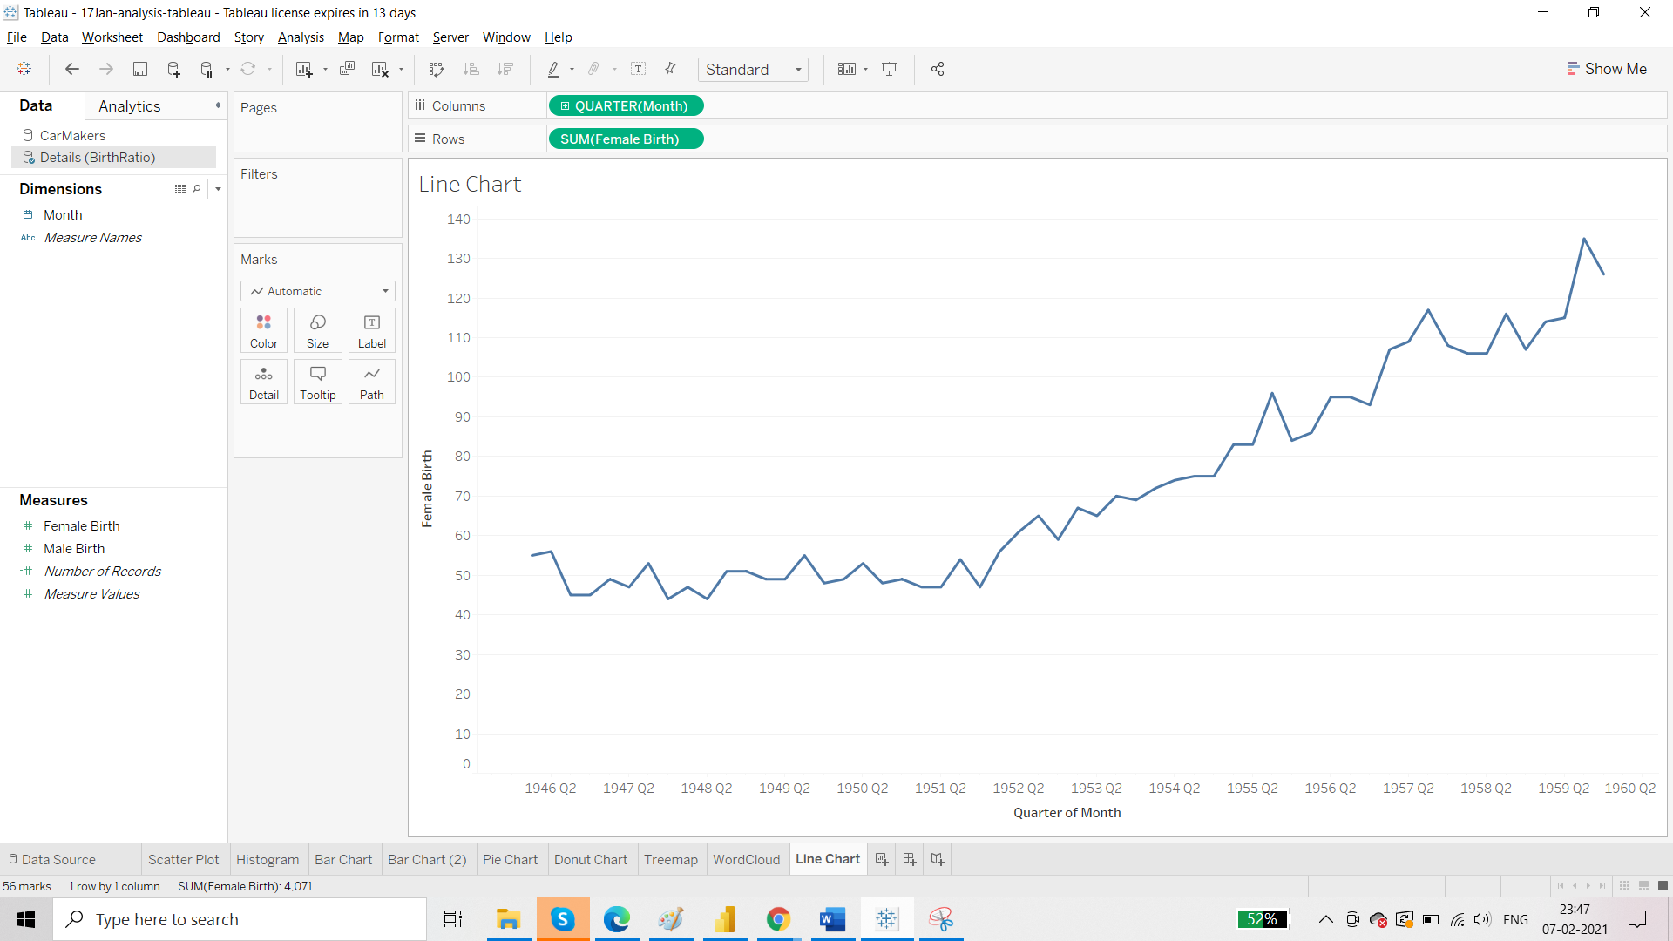

Comparison:

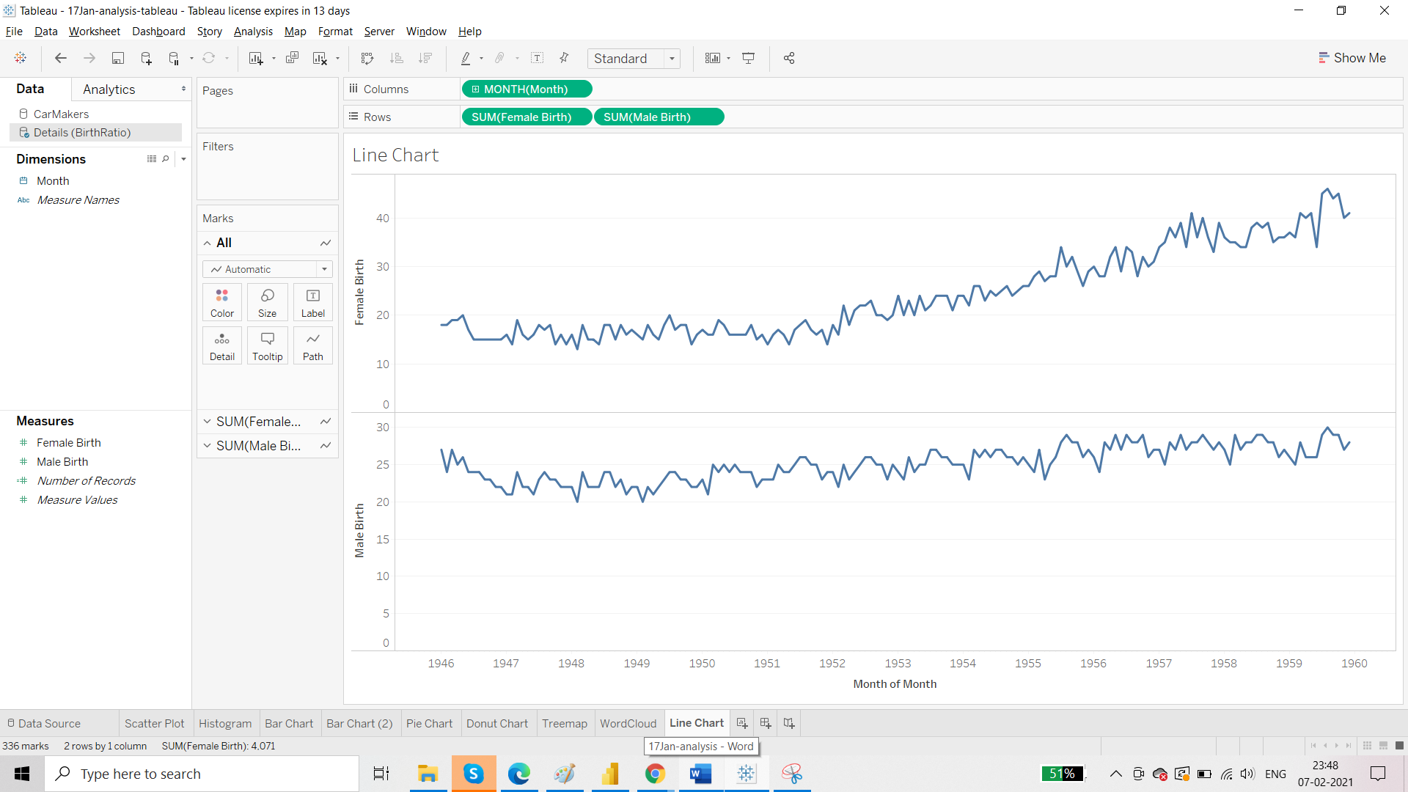

Combining by Dual Axis:

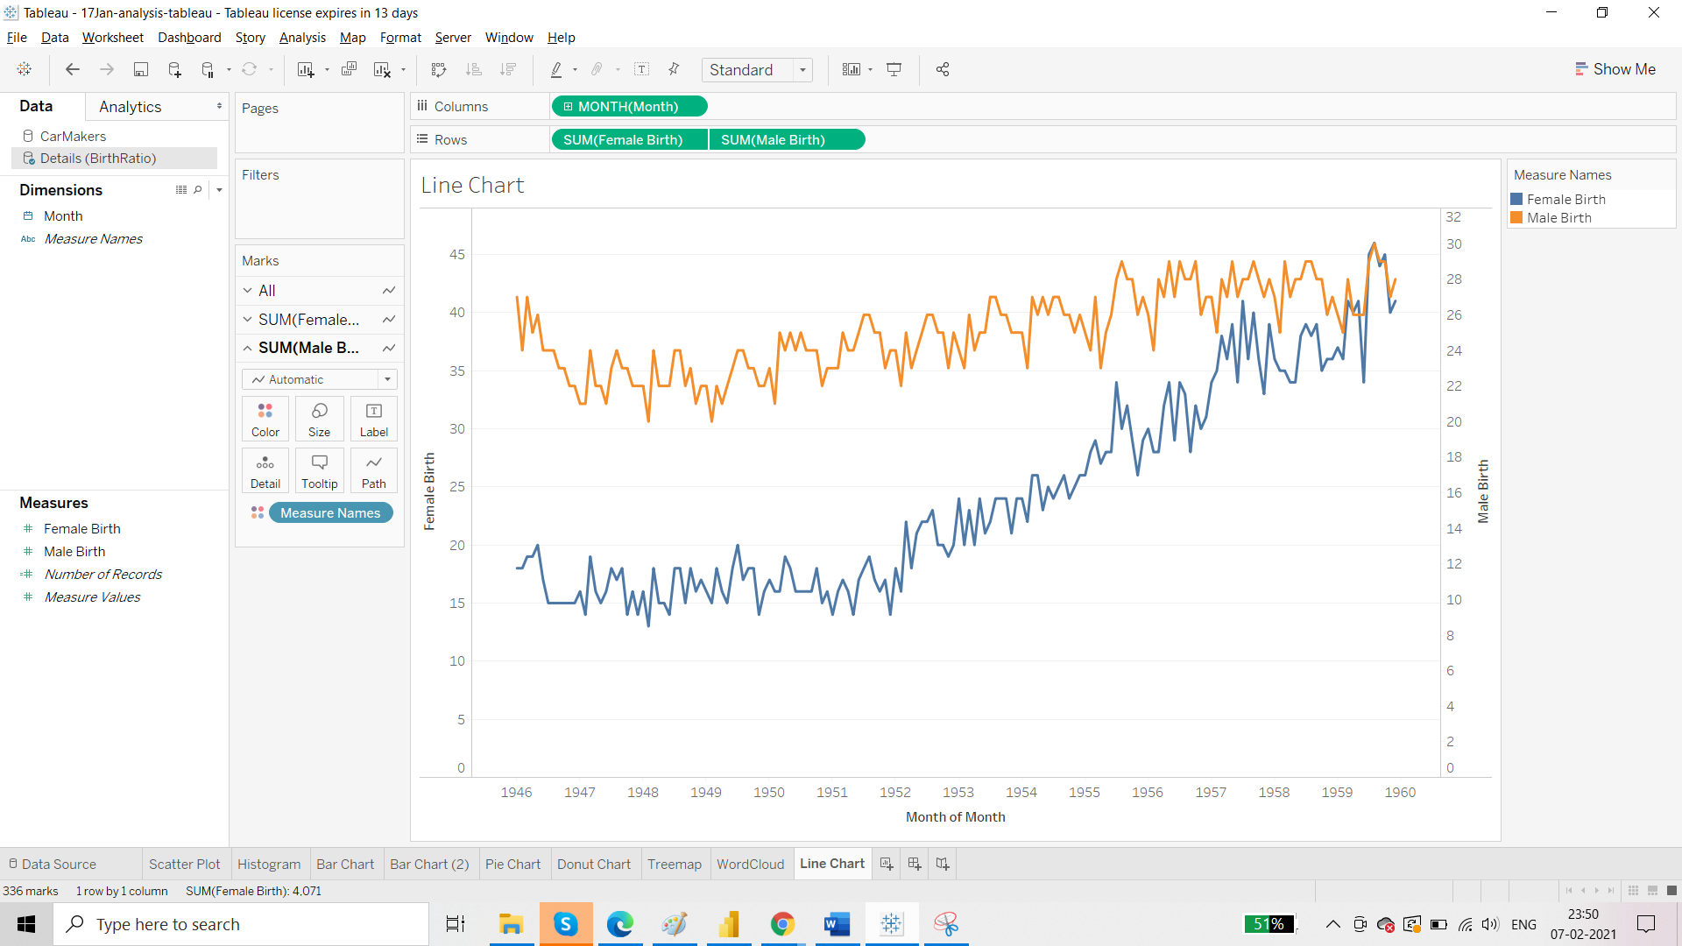

The first flaw: axis values are not same. Sync them.

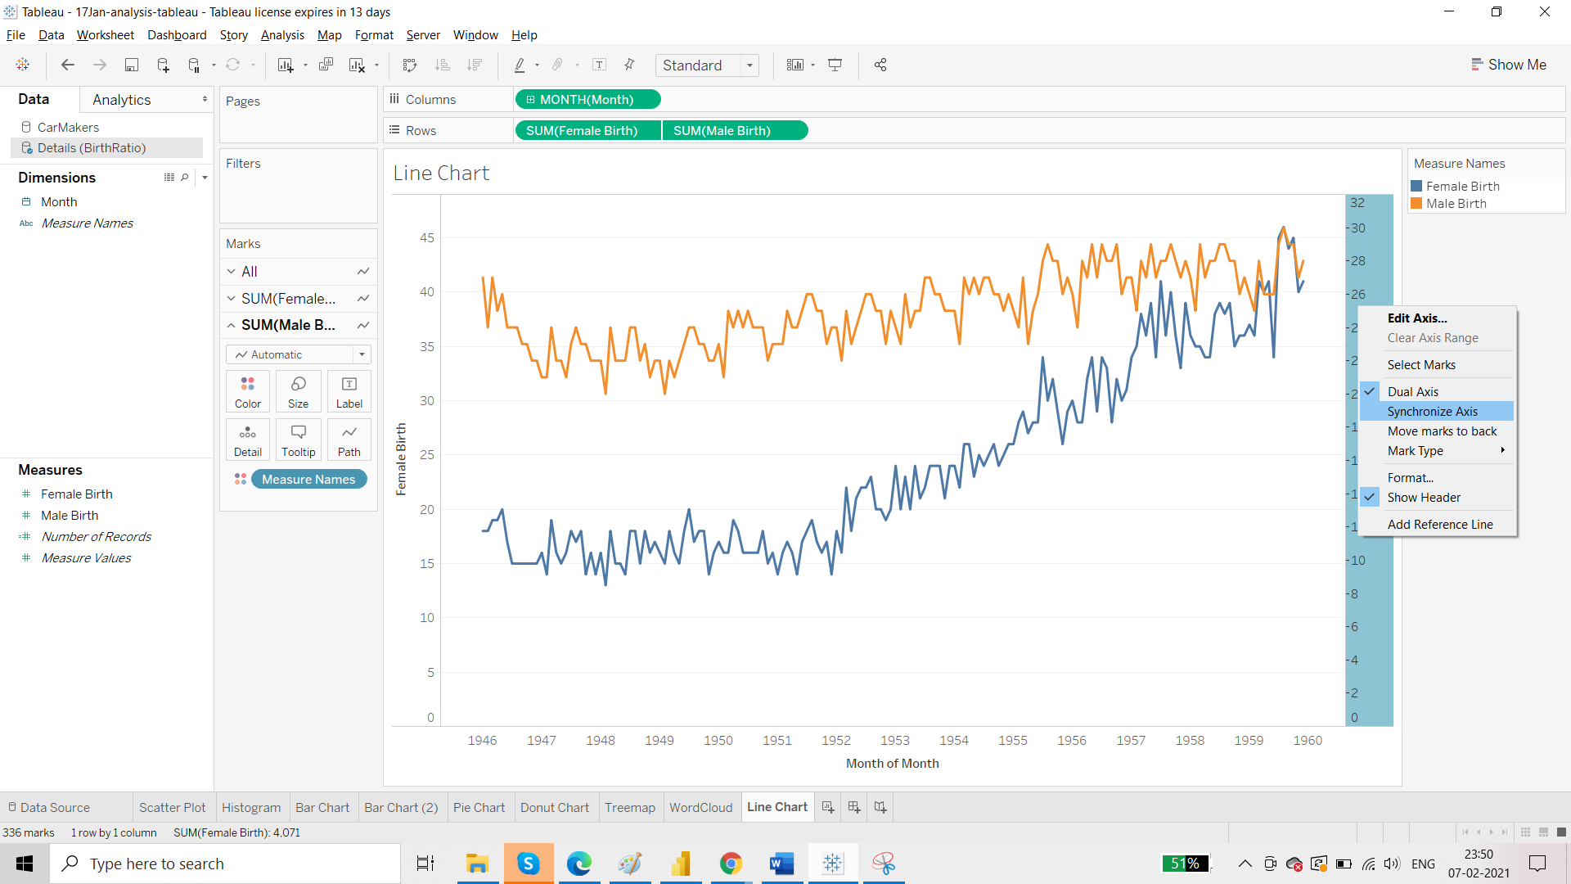

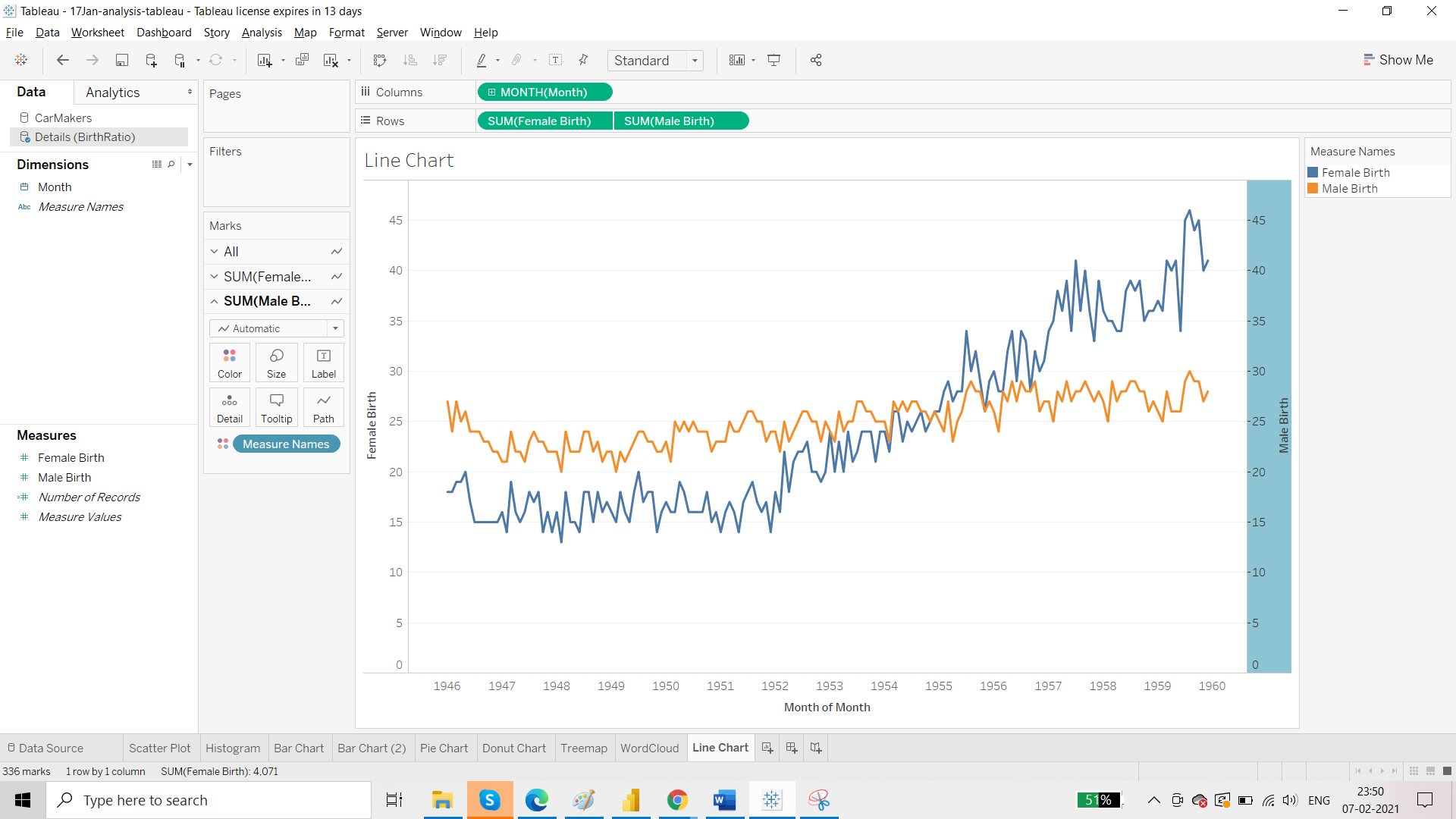

Now one of the axis can be removed. Title can be changed.

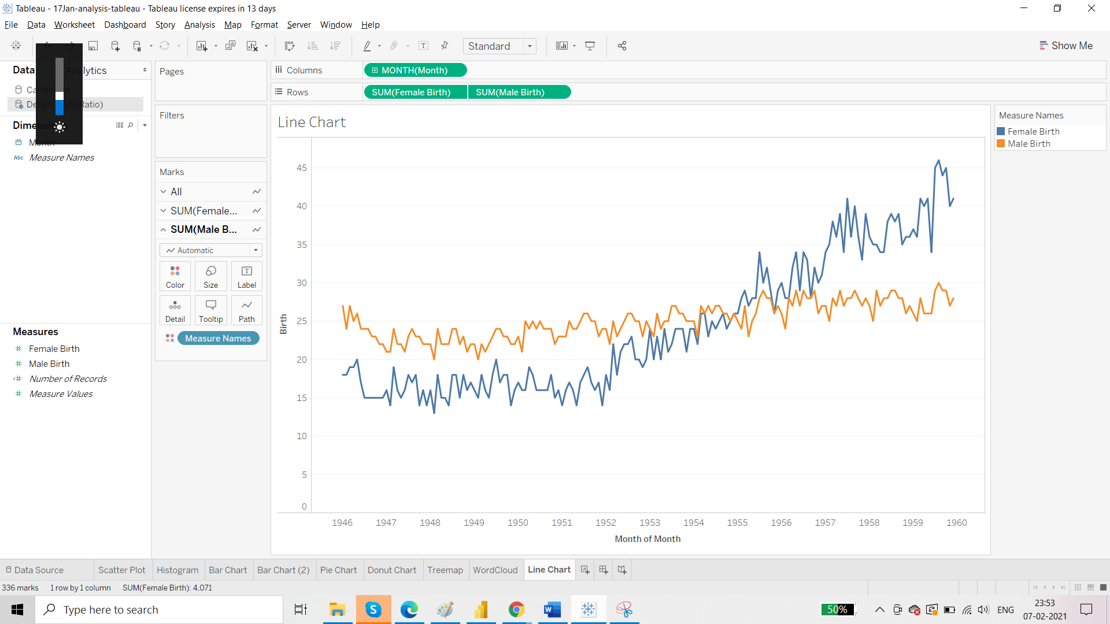

Running Total:

